

**Using the JoVE D2L integration to Add videos to a course** (in  accordion)

Login to your D2L Course, then go to add existing activities

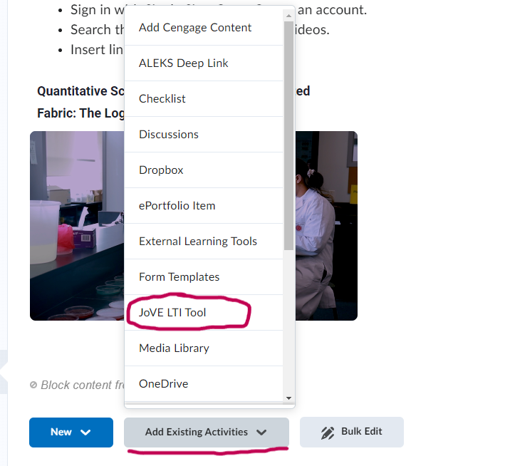

Select to add videos to the course.

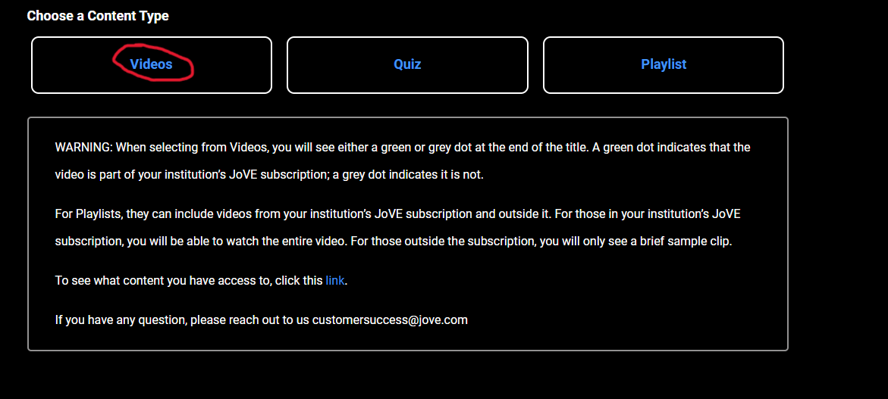

Next, select your subject

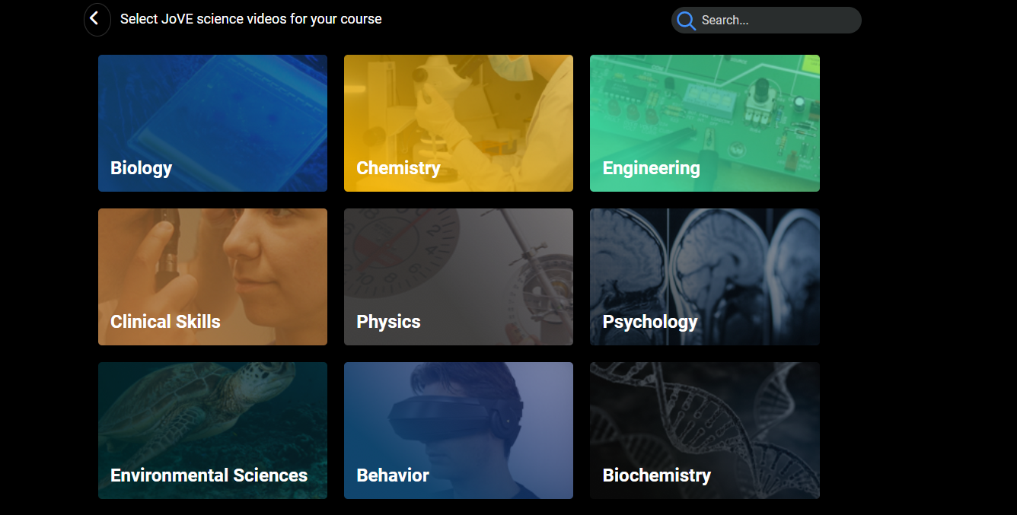

The video for that subject will appear in a list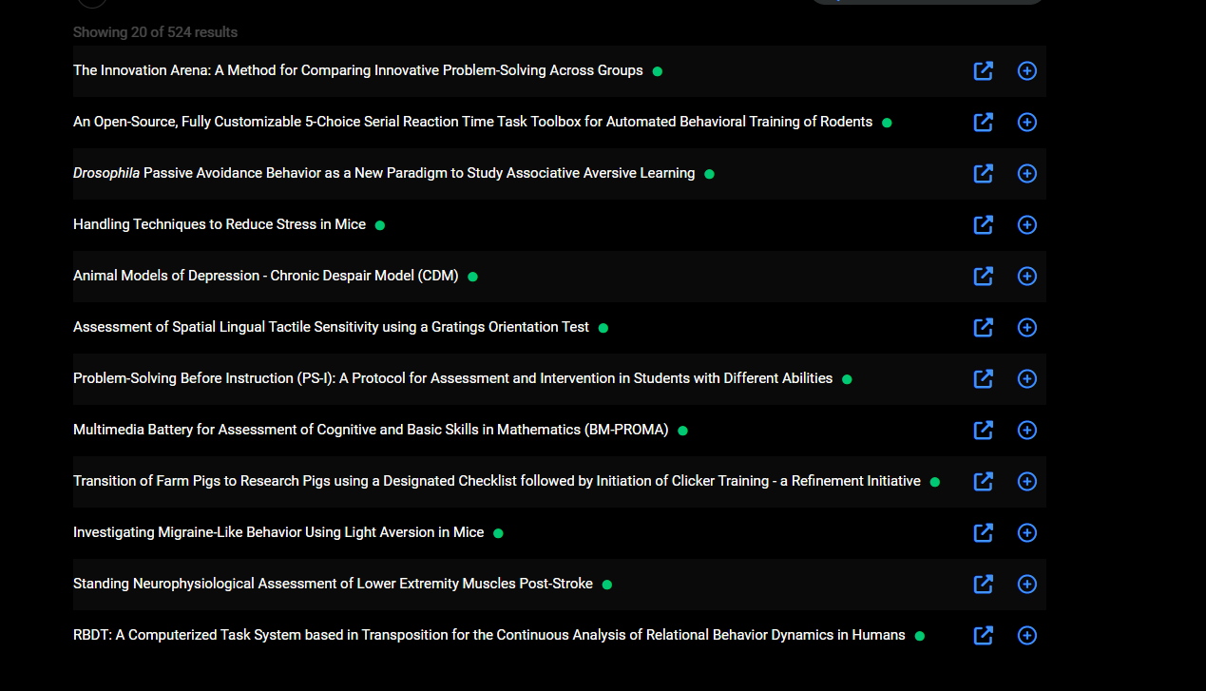

On the lower left side of the screen will be the number of videos pages you have to choose from

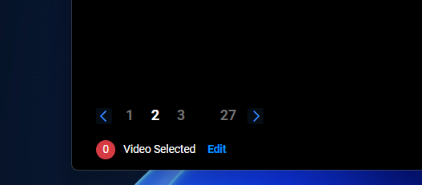

To select videos, click the plus icon, to preview the video hit the tab icon. You can add multiple videos at the same time.

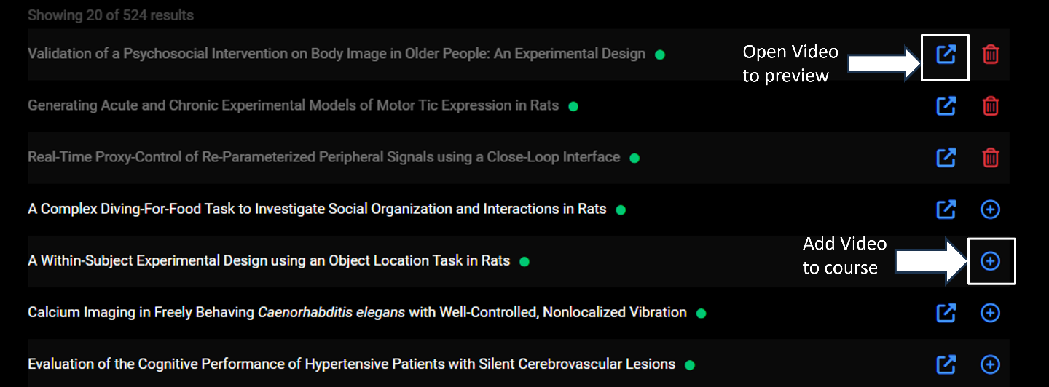

Once you have selected the videos you wish to add, click submit on the lower right side of the screen.

The videos will appear in the course.

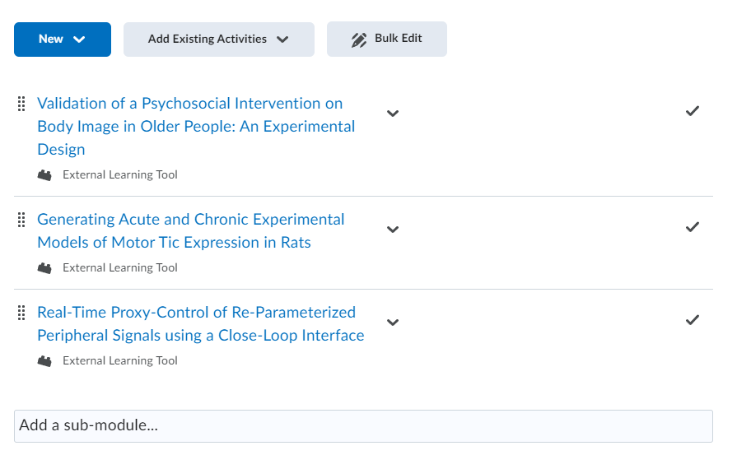

**Using the JoVE D2L integration to Add quizzes to a course** (in  accordion)

Login to your D2L Course, then go to add existing activities

Select to add quiz to the course.

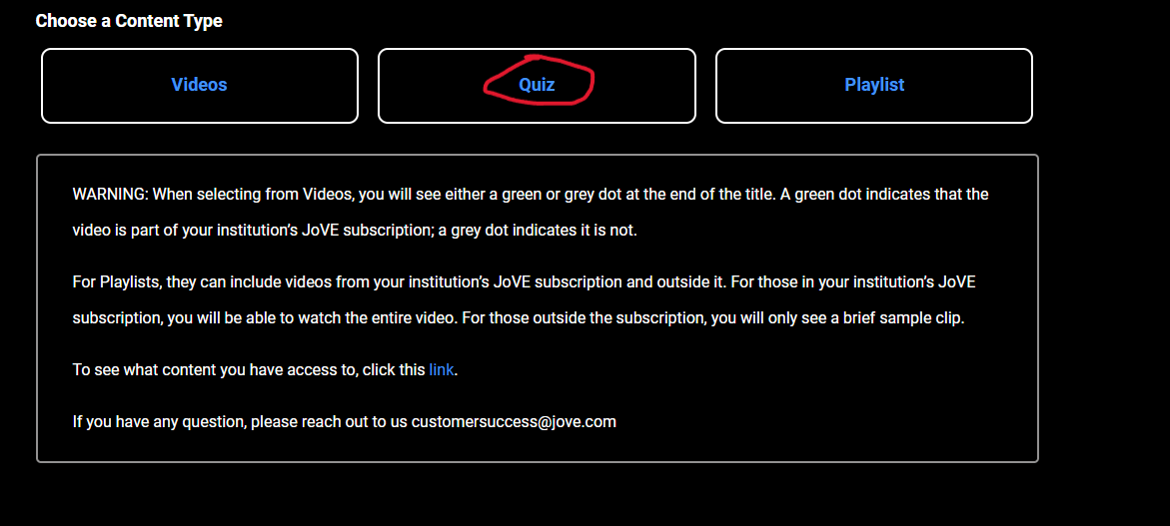

Select Quiz Library. You can search or sort the quiz options.

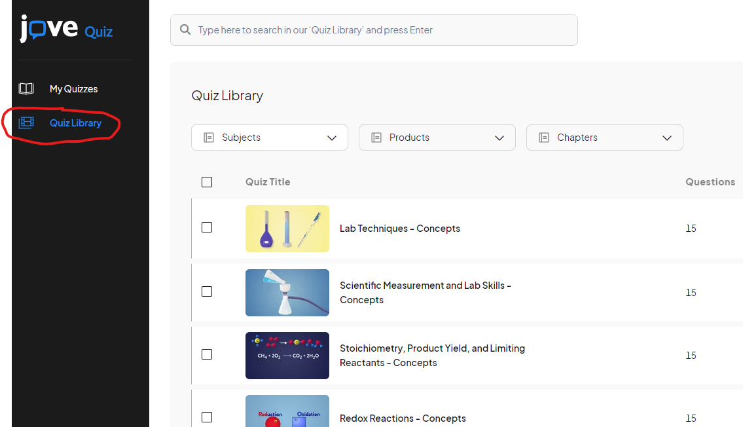

On the right hand side you can preview the quiz and click the plus sign to create a quiz.

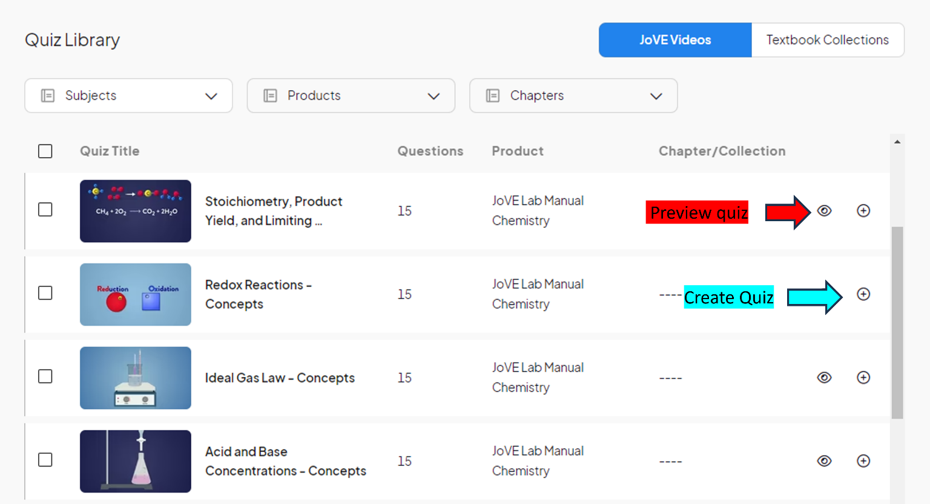

After you select the “create quiz button” you can choose the quiz settings and add a title.

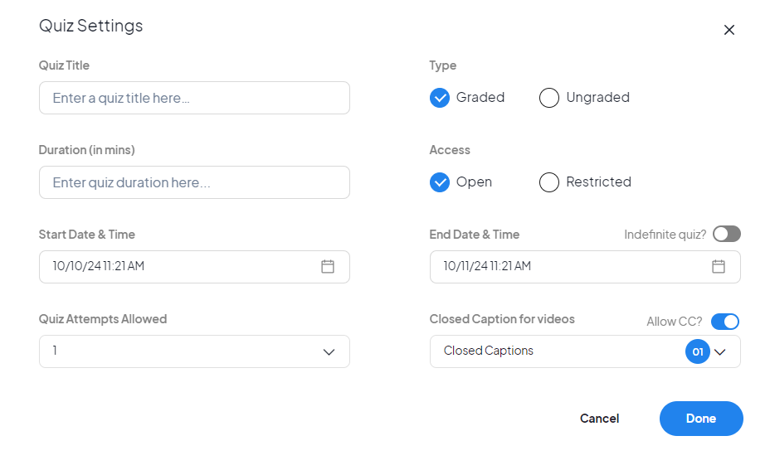

When you are finished click on done.

Next select save and “Back to My Quizzes”

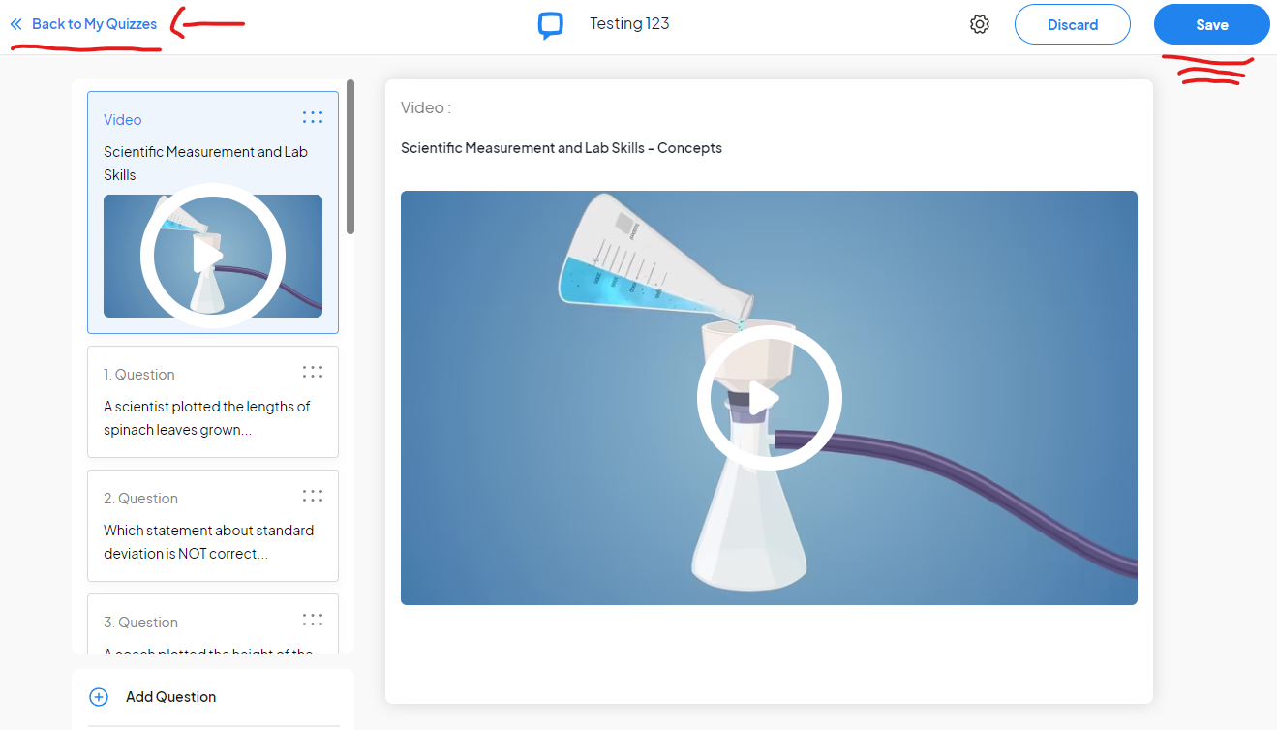

Your new quiz will appear under “My Quizzes”

Under My quizzes select the add quiz plus sign

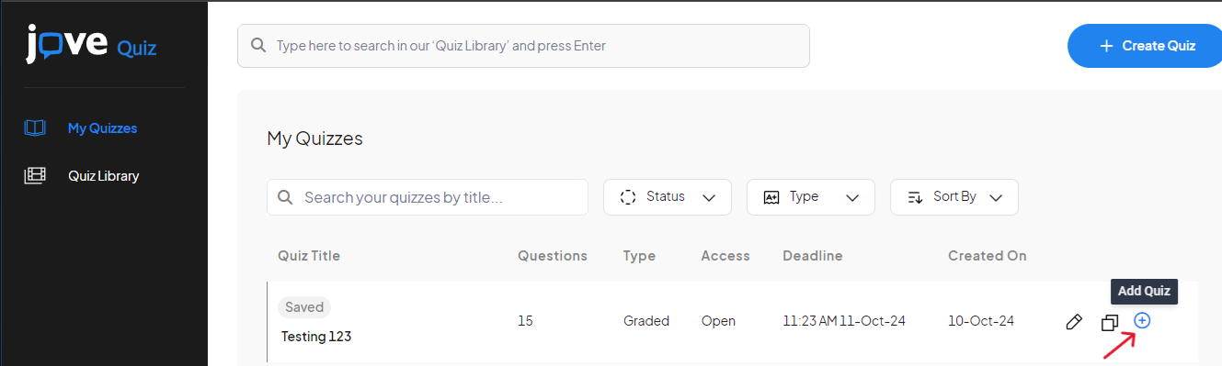

Then select add selected quiz

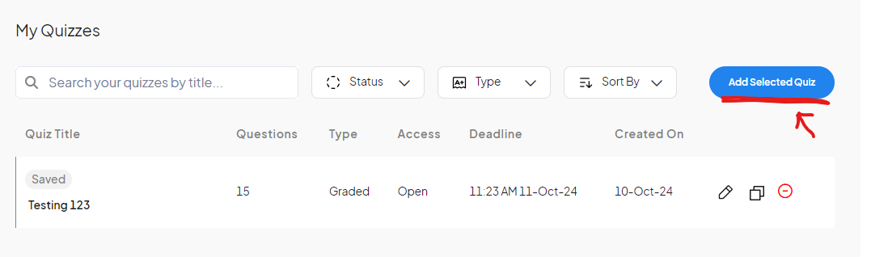

Your quiz will appear in the course

