Communicating with Your Students About AI

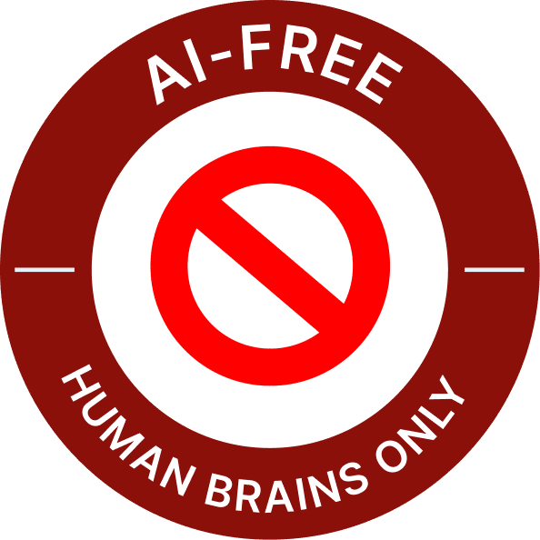 | AI-FREE ASSIGNMENT | No AI use allowed  For learning to happen in this assignment, it’s necessary to do your own thinking without AI assistance.
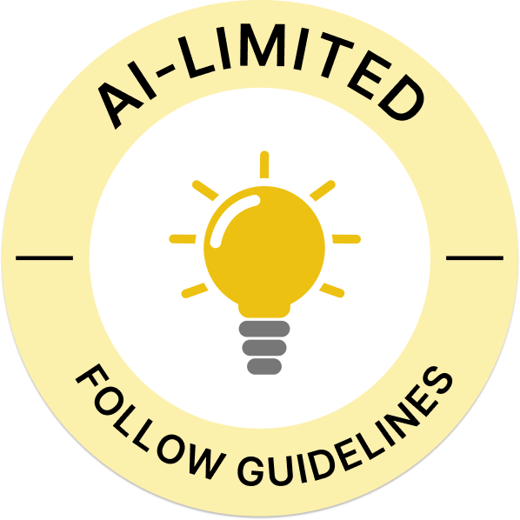 | AI-LIMITED ASSIGNMENT | You can use AI within Guidelines  You can use AI within the guidelines provided in the assignment. Examples include:  - Ideation and Research (AI can be used to help generate ideas, organization and information gathering)  - Limited Word Usage (AI language can be inserted but cited within an assignment)
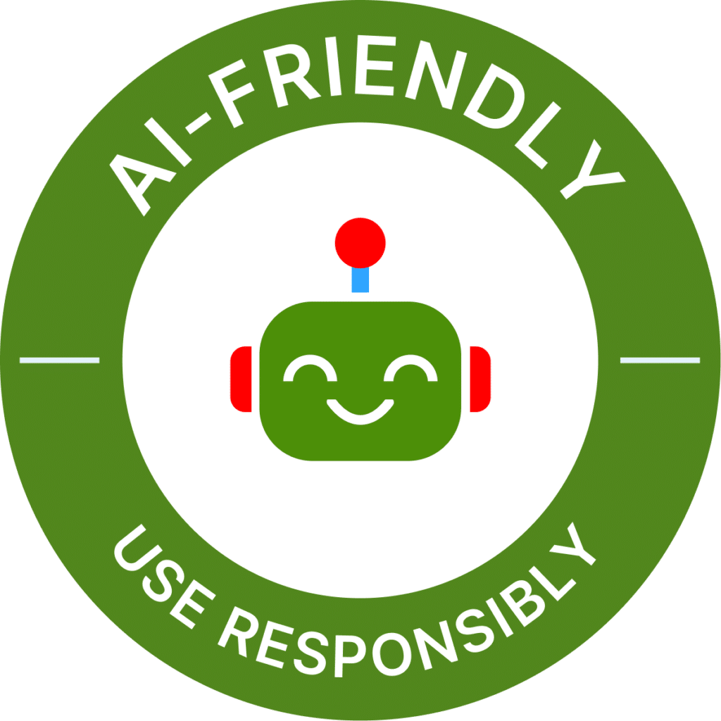 | AI-FRIENDLY ASSIGNMENT | Use Responsibly  You can use AI in this assignment at will, but it should be cited. See this MLA resource for guidance.
Update 7/26/2024
Also, please note that “writing assistance” services like Grammarly now incorporate chatbot features that function like ChatGPT or Gemini, so please flag this for your students if you are asking them not to use generative technologies in their assessed work.

