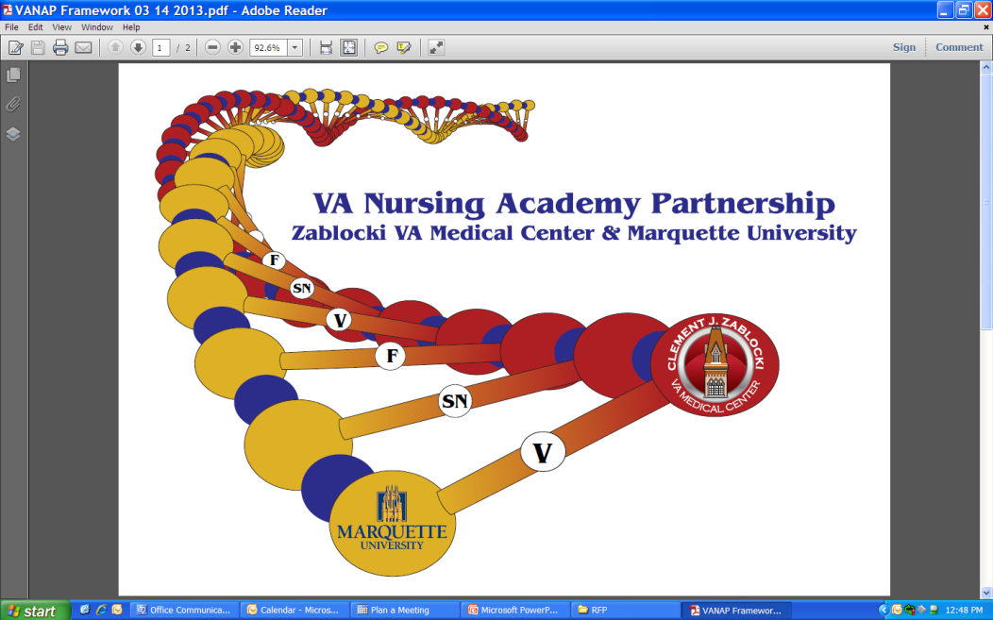
VA Nursing Academic
Partnership (VANAP) Program Application
Marquette University College of Nursing and Clement J. Zablocki VA Medical Center

Undergraduate nursing students interested in veteran-centric care may apply to become a member of VANAP. VANAP nursing students follow the College of Nursing’s pre-licensure curriculum and complete their required adult clinical placements at the Milwaukee VA.

I, _________________________am interested in applying to the College of Nursing’s veteran-centric cohort program. I understand that I must be in good academic standing with the college.

My current GPA is: _________________________________________________________________
Graduating Class: __________________________________________________________________
My email is: _______________________________________________________________________
Name and email of professor for recommendation_________________________________________
(You do not need to have professor supply letter)

I am interested in becoming a member of the VANAP program for the following reasons: (may be hand written or typed).

___________________________________ ________________________
Signature of Applicant Date

This application should be sent to:
Tammy Kasprovich
VANAP Program Director
Marquette University College of Nursing
Clark Hall - 530 N. 16th St.
Milwaukee, WI 53233
414-288-3374
Tammy.kasprovich@marquette.edu

