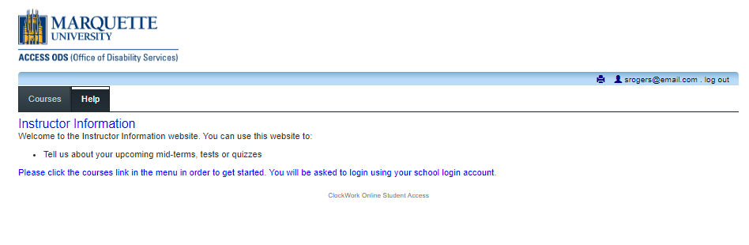

Welcome to the online test proctoring scheduling portal.

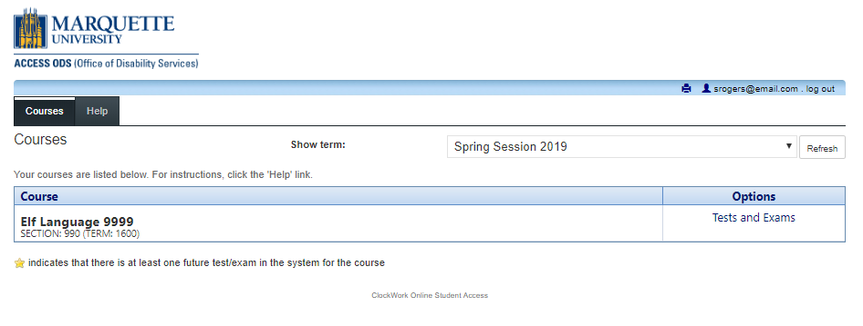
Select the course you would like to schedule your test in.
Click the “Tests and Exams” link on the right.

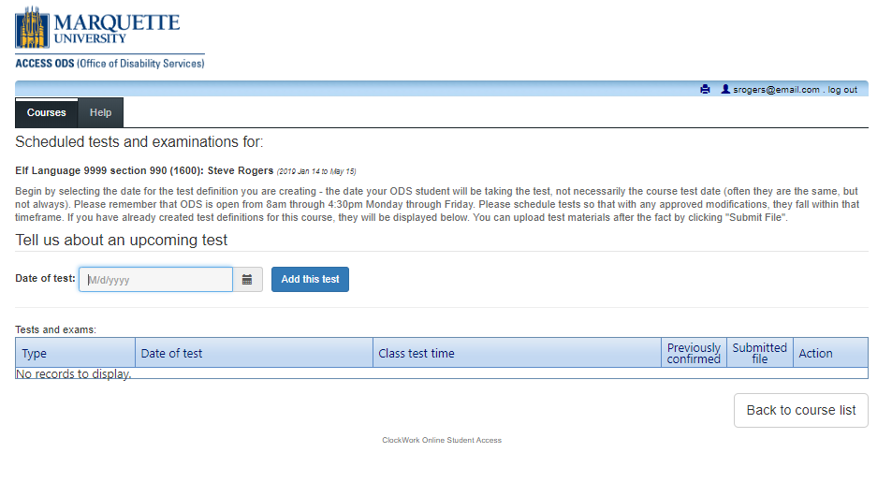
Choose the date your ODS student(s) will take this test. This may not be the same date that your class takes this test.
Click the “Add this test” tab.

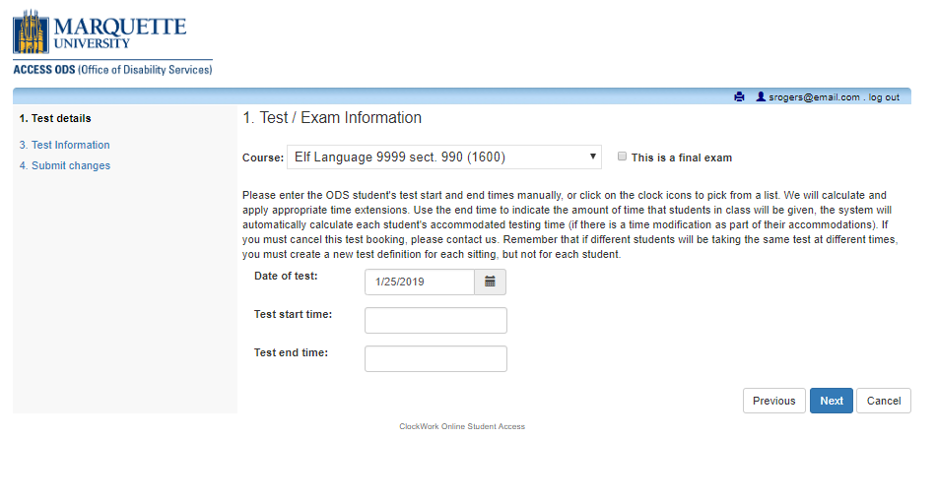

Is this a final exam? Make sure to check this box!

Enter the start time that your ODS student(s) will start this test.
Is the class period 50 or 75 minutes?
The end time above for your ODS student(s) equals the start time plus the class period.
DO NOT add extended time to this end time.

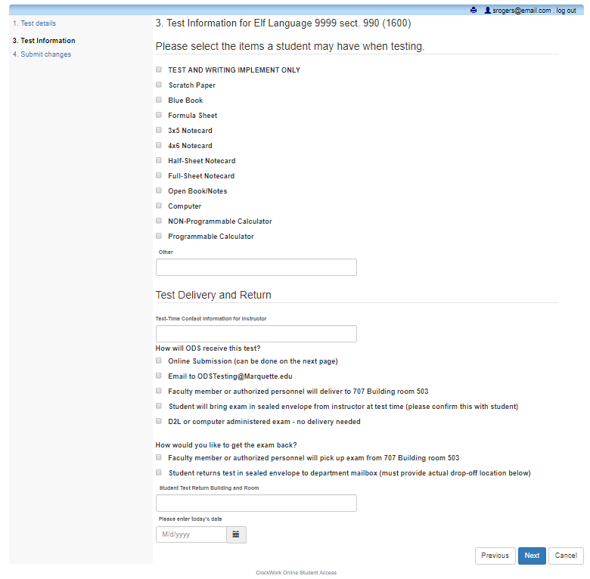

Check all items allowed during the test.
If it’s NOT checked, we will not allow it.

How can we reach you
for questions DURING the test?
How are you getting
this test to our office?
How do you want
this test returned to you?

ENTER A BUILDING,
ROOM NUMBER,
and DATE

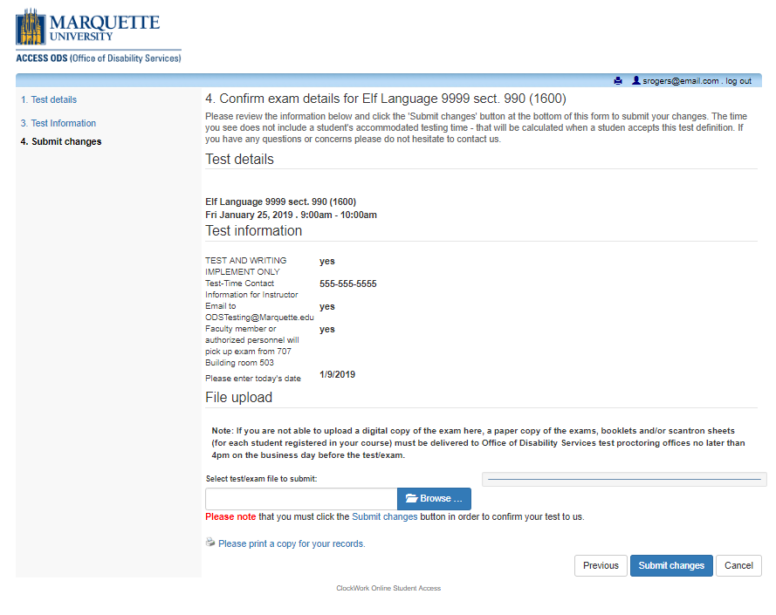

Use this section to verify your test definition.

Upload your test here if using this option.
You can upload as many documents
as necessary for this test.

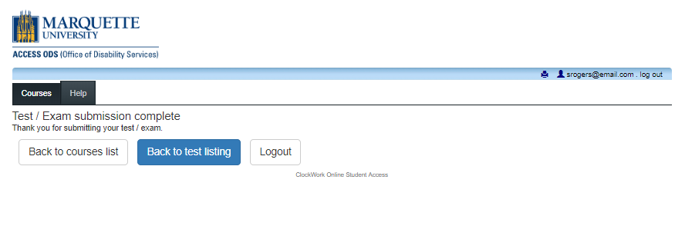
You do not enter any student information. Multiple students can select a single created test definition.
You must create a new test definition for every test date and time.
Test definitions MUST be created 7 calendar days prior to the actual test date.
Refer to the chart below for deadlines.
To schedule Test Proctoring services through ODS:
- Instructors must create the test definitions at least 7 calendar days prior to the actual test date.
- You must accept and confirm the test definitions at least 5 calendar days prior to the actual test date.
If your test is on a: | YOUR INSTRUCTOR must create test definitions by: | YOU must accept test definitions by:
Monday | Monday  of the week before | Wednesday  of the week before
Tuesday | Tuesday  of the week before | Thursday  of the week before
Wednesday | Wednesday  of the week before | Friday  of the week before
Thursday | Thursday  of the week before | Saturday  of the week before
Friday | Friday  of the week before | Sunday  of the week before
IF YOU HAVE ANY PROBLEMS, PLEASE CONTACT US ASAP AT odstesting@marquette.edu

