Gymnasium (ROTC Building)

The Gymnasium building houses campus ROTC offices as well as offices for certain athletic departments.

(Arrow points North)

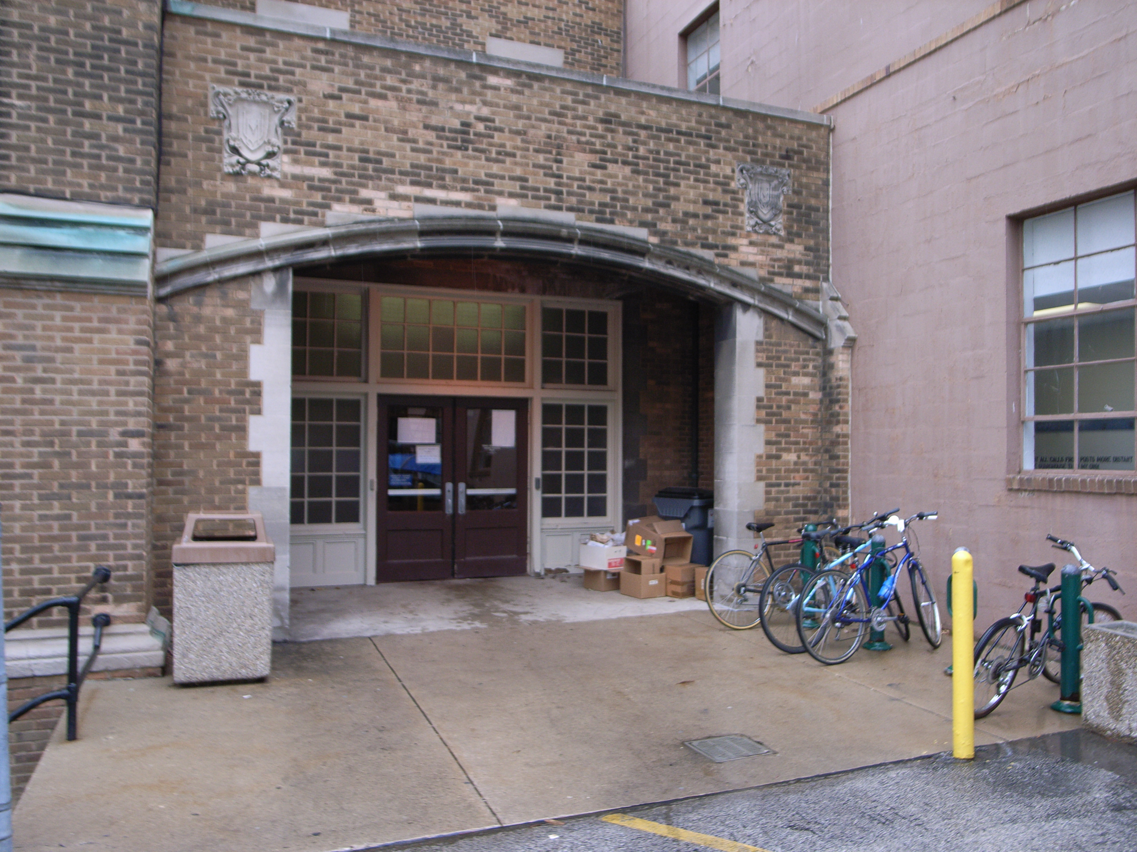

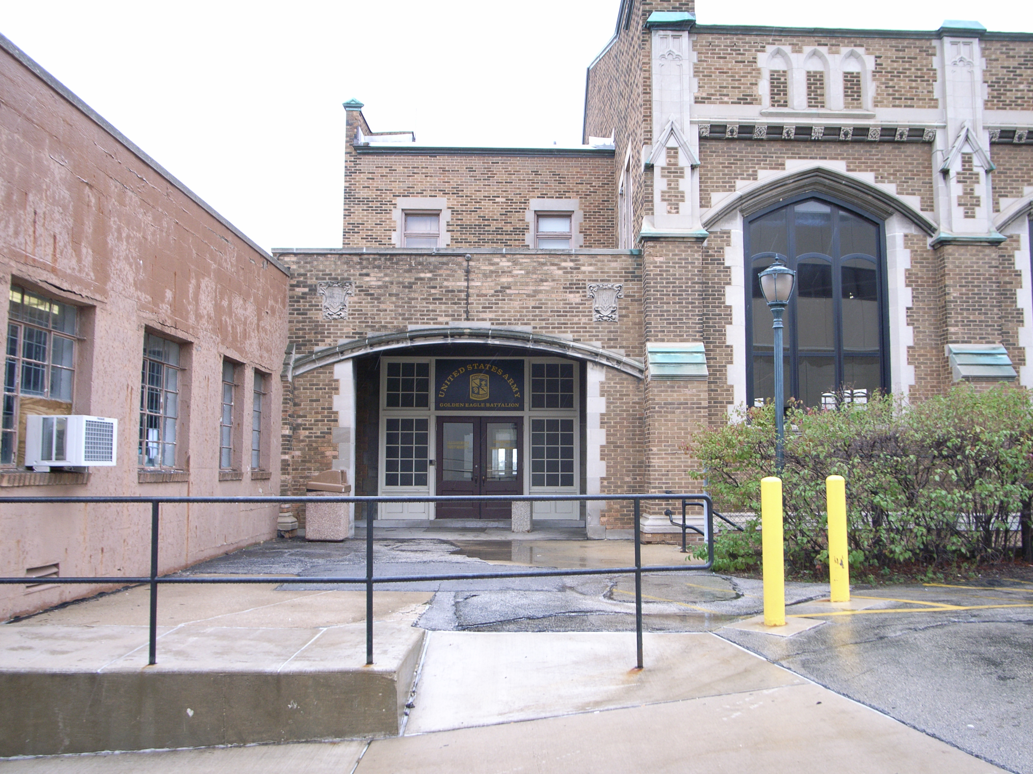

Accessibility

Entrance
West entrance is wheel chair accessible via manual doors

