D2L Quizzes

Objectives:
- Create, edit, and delete quizzes.
- Transfer quiz questions from a quiz to the question library.
- Create a Respondus enabled randomized quiz.
- Grade anonymously.
- Reset, restore, and regrade a quiz attempt.
- Create a quiz that will allow for retaking of incorrect questions only in subsequent attempts.

Contents
Objectives: 1
Getting Started 2
The Question Library 3
Organizing Questions: Creating Sections 3
Creating Questions 4
Previewing Quizzes 5
Types of Questions 7
Editing Questions in the Question Library 24
Creating Quizzes 25
Setting up a Quiz 25
Creating a Quiz with Randomized Questions from a Section in the Library 28
Editing and Deleting Quizzes 35
Moving Questions from a Quiz to Question Library 37
Grading Quizzes 38
Grading an in-progress quiz 40
Troubleshooting Tips for Quiz Scores not Publishing to grade book 41
Anonymous Grading 42
Reset or Restore a Quiz Attempt 45
Regrade after updating a quiz attempt 47
Retake Incorrect Questions Only 49

Getting Started

Overview:
Create low to high-stakes assessments online. Grades automatically export to the gradebook. Best practice is to build the questions in the question library first to import to any quiz. Preferred browser is Firefox.
Useful Terms:
Question Library: The Question Library works as a question bank from which you can select questions when you’re creating a quiz. It is the central space to keep questions organized by topic, question type, etc. It is recommended that you build your questions directly into the Library so it can be imported to a quiz.
Section (in the Question Library and Quizzes): These work like folders which allow you to organize your questions by topic, unit, or type of questions, etc. You can set specific parameters to a section in your quizzes, such as question randomization.
Question Pool: Set a given number of questions randomly selected from a section in the Question Library.
Categories: Allow you to group quizzes under a Category in the Quizzes Page. For example, Unit 1 Quizzes.
Quizzes Page: Once in your course, click on Quizzes under Assessments on the Main Navigation Bar. You will be taken to the Quizzes Page where you can manage quizzes, access the Question Library, review quiz statistics and enable LockDown Browser.

The Question Library

Accessing your Question Library
- Click on Assessments > Quizzes on the Main Navigation Bar.
- Click on Question Library on the top menu of the Quizzes Page.

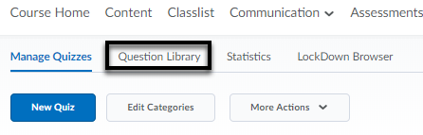

Organizing Questions: Creating Sections
- In the Question Library, click on New and choose Section (folder) from the drop-down menu.
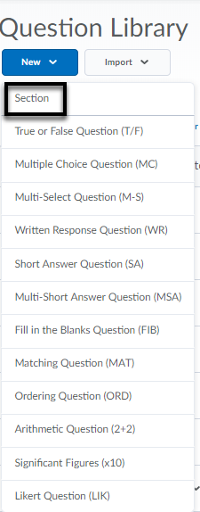
- Enter a name for the section.
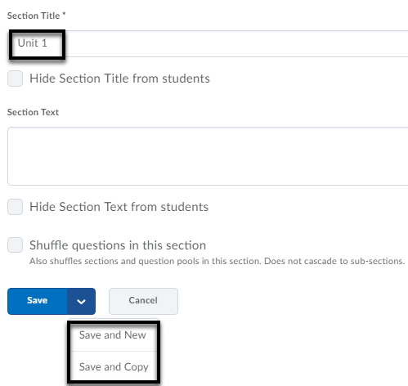
- Click Save (if you want to add other types of questions) or the option to Save and New (create a new question of the same type) / Save and Copy (create a new question with the current question as a template) by clicking the drop-down menu.
- The section will show up in the Question Library and in the menu to the left.

Creating Questions

- In the Question Library, click on the Section where you want to add questions.

Note: The sections can be accessed by clicking on the folders in the “tree” on the left side of the library.
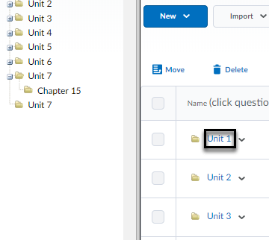
- Click New and choose the type of question that you want. There are 12 question types, and the process for creating each question is slightly different. You can also add text or image information.

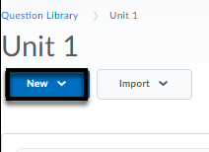
Note: Import button can only accept CSV formatted text files. D2L provides a download template of question type structures for a CSV file. IMPS QTI compliant course package (ZIP) file is acceptable. It is also possible to import existing questions from other course quiz folders.

- In the Question Text field enter the question.

Note: If you copy and paste text into the question text box, clear formatting. For example, if clearing formatting on a Word document, highlight the text and under Styles, click Clear Formatting.

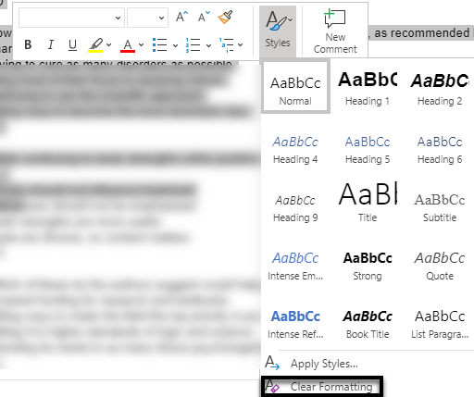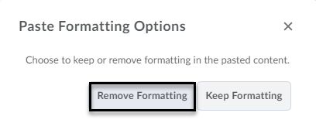

If clear formatting of text is not completed, then select Remove Formatting when text is pasted in a text box in D2L.

Enter the points and click Save (if you want to add other types of questions) or Save and New (to create another question of the same type) or Save and Copy (create a new question with the current question as a template).

Previewing Quizzes
- Click Quizzes from the Assessments (main navbar) drop-down menu.
- Click Edit from the drop-down menu next to the quiz name.
- Select Add/Edit Questions.
- Click Preview (upper right-hand of the page).

Types of Questions
There are 12 different question types. It is best practice to use the Preview button for each individual question as well as the entire quiz to test for accuracy before a quiz is released.
Many quiz question types give the option to insert an image via rich text editor in the question text box. All question types allow you to include Feedback and Hints under the Options menu. Other options may be available depending on the question type (e.g., short description, add enumeration).
If you choose to enable LockDown Browser and Monitor for Written Response, Arithmetic or Significant Features type questions, do not check the option to Enable inserted images and attachments or Allow attachments to support answers. It will cause a security risk.
Click Save (if you want to add other types of questions) or Save and Copy (create a new question with the current question as a template) or Save and New (to create another question of the same type).

True or False Question

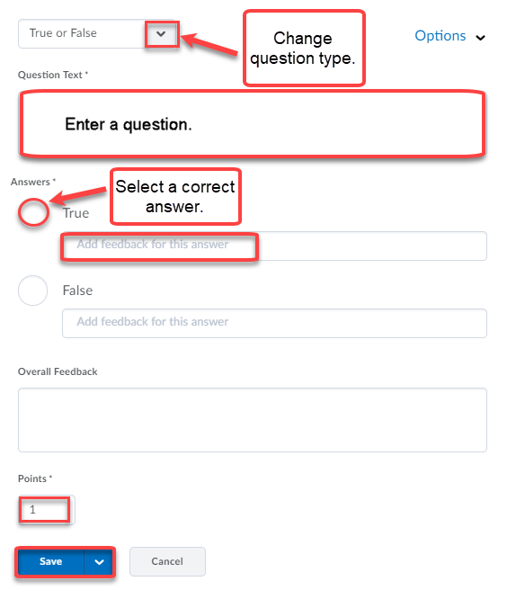

Multiple Choice Question
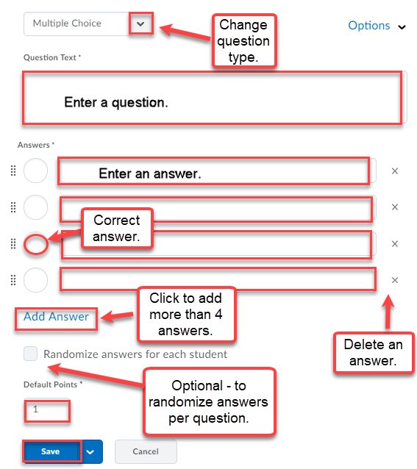

Note: Do not select Randomize answers if the answer is “All of the above.”
Click Save (if you want to add other types of questions) or Save and Copy (create a new question with the current question as a template) or Save and New (to create another question of the same type).

Multi-Select Question
Multiple-Select option allows the students to select more than one right answer.
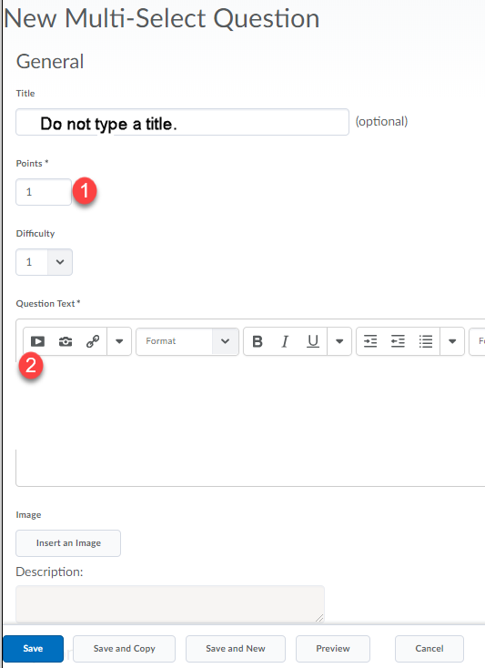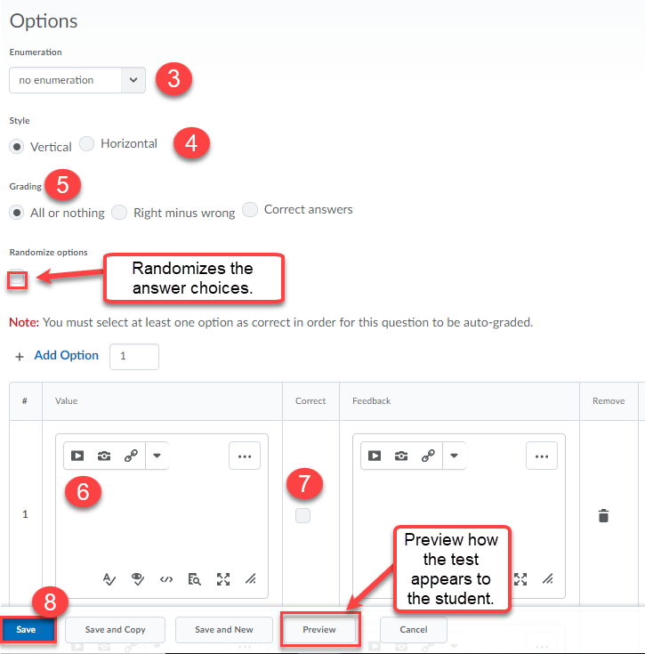
- Enter the point value for the question
- Type the question in the Question Text box
- Select the Enumeration style in the drop-down list
- Select a Display Style: Vertical or Horizontal
- Pick a Grading format
  - All or nothing: If students select all the correct components correctly, they receive full credit. If they miss an option, the entire question is wrong.

  - Right minus wrong: students receive points equal to the number of right answers they choose minus the number of incorrect answers they choose. To determine how much each answer is worth, the system takes the total number of points assigned to the question and divides it by the total number of points assigned to the questions and divides it by the total number of answer choices.

Example: If a question is worth 10 points and 5 answer choices, each correct answer is worth two points (10/5=2). If the student gives 3 correct answers and 2 incorrect answers, 2 is the total number of points received for the questions [(3-2)]*2=2]

Note: Students can receive a zero for a question but not a negative number.

  - Correct Answers: Students receive points for each correct answer they select and for each incorrect answer they leave blank. Incorrect answers selected and correct answers left blank are ignored.
Example: Consider a question with a total of six potential answers, two answers being correct (in this case, choices a) and b) are the correct choices). The total point available for this question is 4.
- Enter the options in the value boxes
- Select the correct option(s)
- Click Save (if you want to add other types of questions) or Save and Copy (create a new question with the current question as a template) or Save and New (to create another question of the same type).

Note: Do not select Randomize answers if the answer is “All or None of the above.”

Written Response (Long Answer Essay Question)

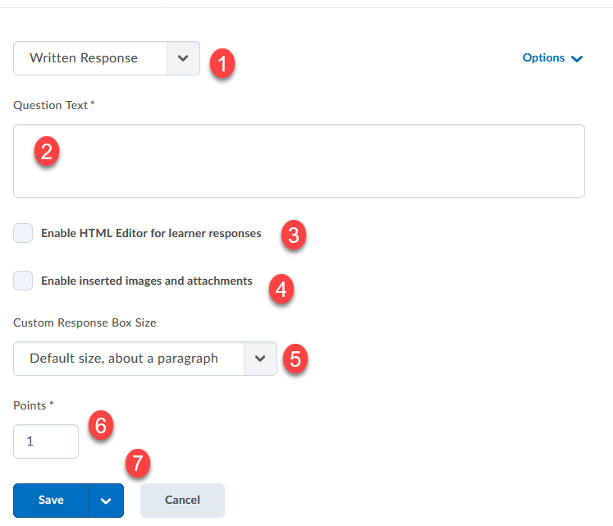
- Use drop-down to change question type.
- Enter question text. Once you click within the text box, the toolbar should appear.
- Enable HTML editor for learner responses to allow students access to the rich text editor, embed objects, formulas, etc. Note: If a student refreshes the page while taking the quiz, the HTML code is sometimes stripped from saved written responses. As a best practice, encourage users to save a version of their HTML response locally in case they need to refresh the page.
- Insert image or add attachments option allows students the ability to upload files or insert images. Note: If you enable LockDown browser, it is not necessary to select attachment option since the students will not be able to attach files. In LockDown, it is suggested that the instructor attach an Excel file type (no other file types are acceptable) for students to edit, then save and paste into the response box. The student D2L guide labeled “Written Response with LockDown” provides steps for students to follow when given a written response question in a LockDown Browser enabled quiz.
- Under the Options menu, you can enable Custom Response Box Size. There are three options for a custom response size. The default size is about a paragraph. Therefore, if the response should be shorter (e.g., a sentence) or longer (e.g., essay), select the drop-down menu to change the size response.
- Enter point value.
- Click Save (if you want to add other types of questions) or Save and Copy (create a new question with the current question as a template) or Save and New (to create another question of the same type).

Under the Options drop-down menu,
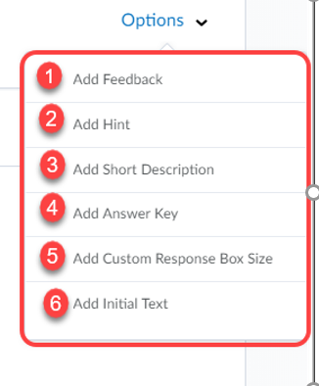
Add Feedback text box shows up after the assessment has been completed. [1]
Add Hint text box will show up as the assessment is being completed. [2]
Add Short Description to the question. [3]
Add Answer Key will guide the grading and is visible to all users with Grades permissions. [4]
Add Custom Response Box Size will customize the size of the response box. There are three options for a custom response size. The default size is about a paragraph. Therefore, if the response should be shorter (e.g., a sentence) or longer (e.g., essay), select the drop-down menu to change the size response. [5]
Add Initial Text will be viewed by students to complete the student response. [6]

Short Answer Question
The short answer question is intended for a one word or brief sentence answer response to an open-ended question. Designate the number of points assigned to the blanks by clicking the drop-down menu to select one of two options:
- Students receive part marks: Students receive points for each correct answer blank.
- Students must answer all blanks correctly: Student must answer all the question blanks correctly to receive points.
Click Save (if you want to add other types of questions) or Save and Copy (create a new question with the current question as a template) or Save and New (to create another question of the same type).
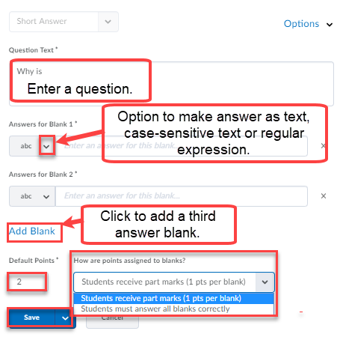
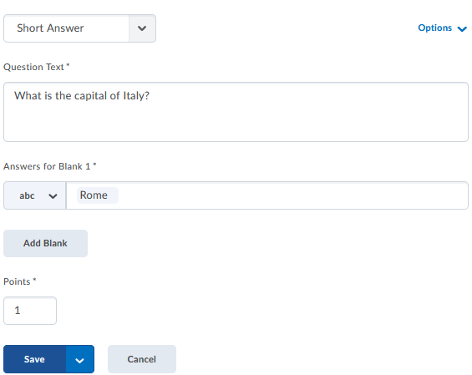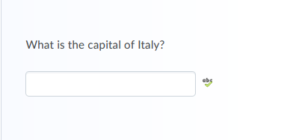

Multi-Short Answer Question
This question allows for multiple correct answers to a single question. This differs from the short answer question because of the multiple answer boxes to one answer set.
Click Save (if you want to add other types of questions) or Save and Copy (create a new question with the current question as a template) or Save and New (to create another question of the same type).

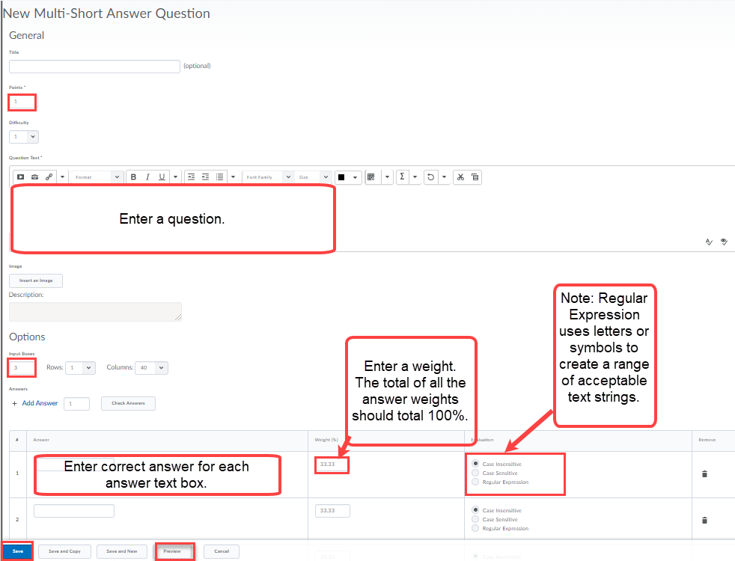

Fill in the Blanks Question
It is recommended that answers in the blank fields be no more than one or two words to ensure auto-grading accuracy. Select Case Insensitive or Regular Expression Evaluation option. An example of regular expression is gre[ae]y to allow for alternative spellings. To provide full credit for the answer, enter 100%.
Click Done after previewing. Click Save (if you want to add other types of questions) or Save and Copy (create a new question with the current question as a template) or Save and New (to create another question of the same type).

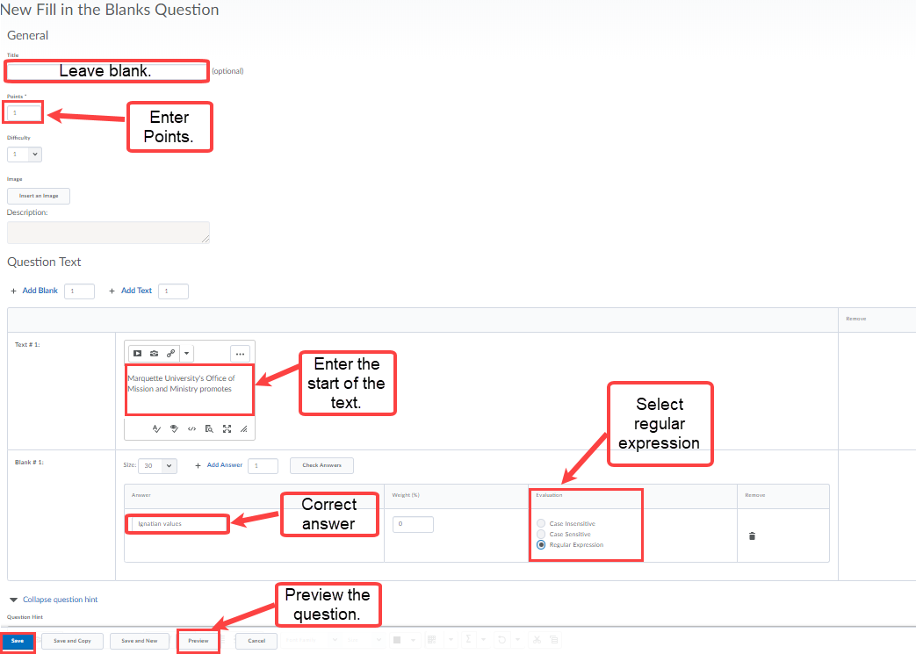
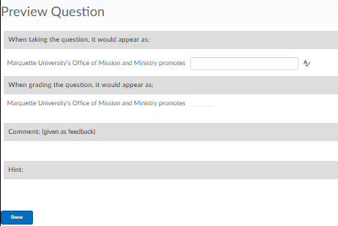
Matching Question
- Enter a Points value
- Enter your question (or instructions) in the Question Text field.
- Choose a Grading format:
  - Equally weighted: The total point’s value is divided equally among all possible correct matches. Users receive equally weighted points for each correct answer.
  - All or nothing: Users receive the total point’s value for correctly matching every answer. If any answer is incorrect, the student receives a zero.
  - Right minus wrong: Users receiver points equal to the number of right answers they choose minus the number of incorrect answers they choose. To determine how much each answer is worth, the system takes the total number of points assigned to the question and divides it by the total number of answer choices.
Example: If a question is worth 10 points and has 5 answer choices, each correct answer is worth 2 points, and
each incorrect answer is worth 2 points (10/5=2). If a user gives 3 correct answers and 2 incorrect answer, 2 is the total number of points received for the question [(3-2)]*2=2]
- Click Add Choice to create more answer choices. Enter an answer choice in each choice Value field.
- Click Add Match to create more matches. Enter a match choice in each math Value field.
Note: The list of matches will show up for students on the left and is randomized each time the question is taken. Choices show up on the right and are always the same.
- Select the corresponding choice number in the Correct Choice drop-down menu next to a match value. This creates a matched pair.
- To reduce the number of choices and matches available, click the corresponding Remove Option icon.
- Optional: Provide comments and suggestions in the Question Hint and Question Feedback fields.
- Click Preview to view your question. Students select their match choices from the drop-down menu. Click Done after previewing.
- Click Save to return to the main page, click Save and Copy to save and create another Matching question that retains the copied properties, or click Save and New to continue creating new Matching questions.

Matching Question (continued)

Click Save (if you want to add other types of questions) or Save and Copy (create a new question with the current question as a template) or Save and New (to create another question of the same type). Note: Choices can have multiple matches.
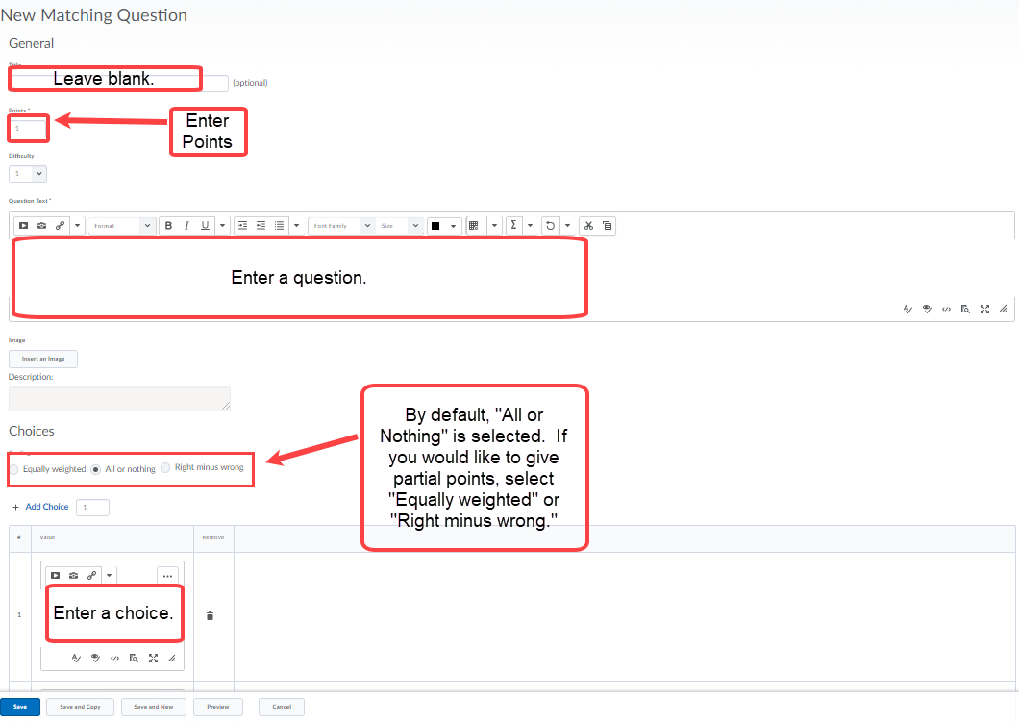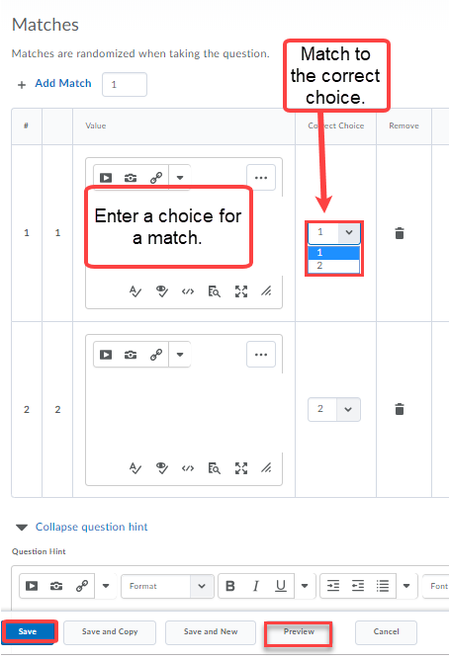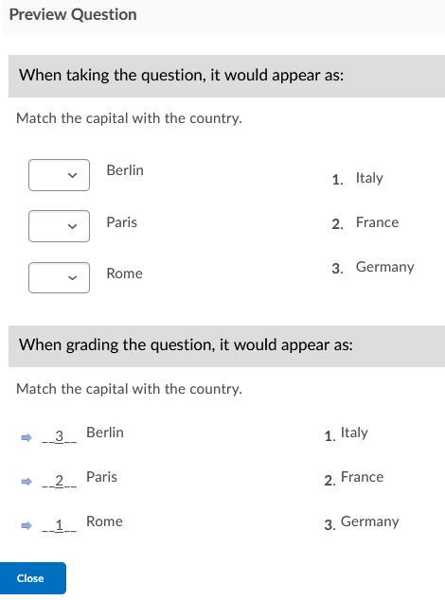
Ordering Question
This question is intended to get learners to identify the sequence of events. Click Save (if you want to add other types of questions) or Save and Copy (create a new question with the current question as a template) or Save and New (to create another question of the same type).
Note: Items are automatically randomized.

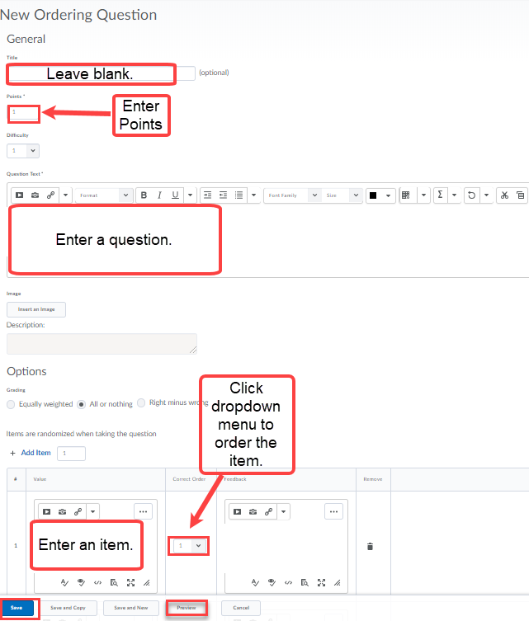

Arithmetic Question
Use “enforce precision” to limit the number of decimal places allowed in an answer. Allow an attachment option for student documents is available. Click Save (if you want to add other types of questions) or Save and Copy (create a new question with the current question as a template) or Save and New (to create another question of the same type).
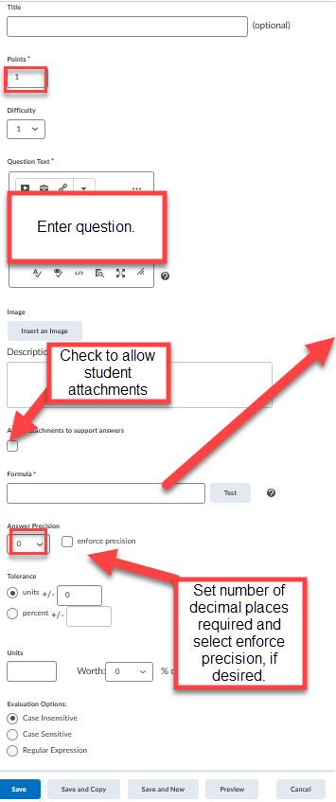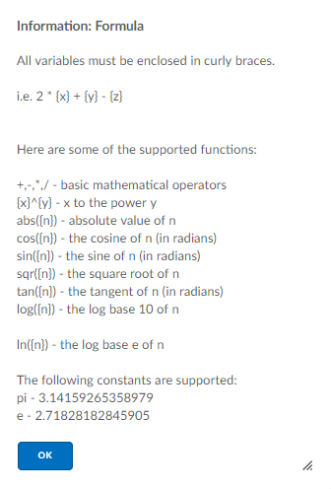
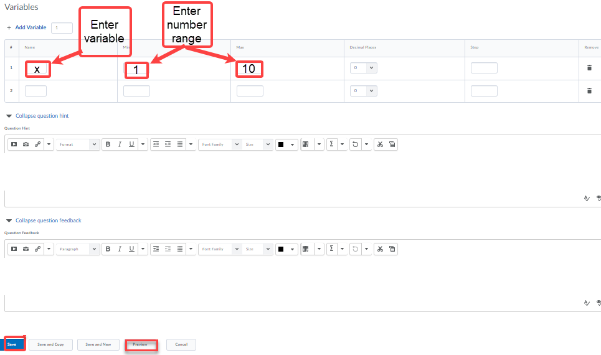
Preview question after entering question, formula, and variables.
Significant Figures Question
Use tolerance levels to accept answers by a certain percentage or number of units (estimated, rounded or near accurate). Select a percentage of the answer’s score to deduct for incorrect significant figures. Allow an attachment option for student documents is available.
Click Save (if you want to add other types of questions) or Save and Copy (create a new question with the current question as a template) or Save and New (to create another question of the same type).
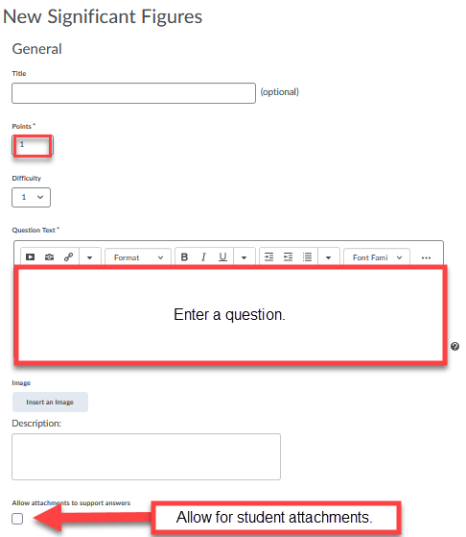
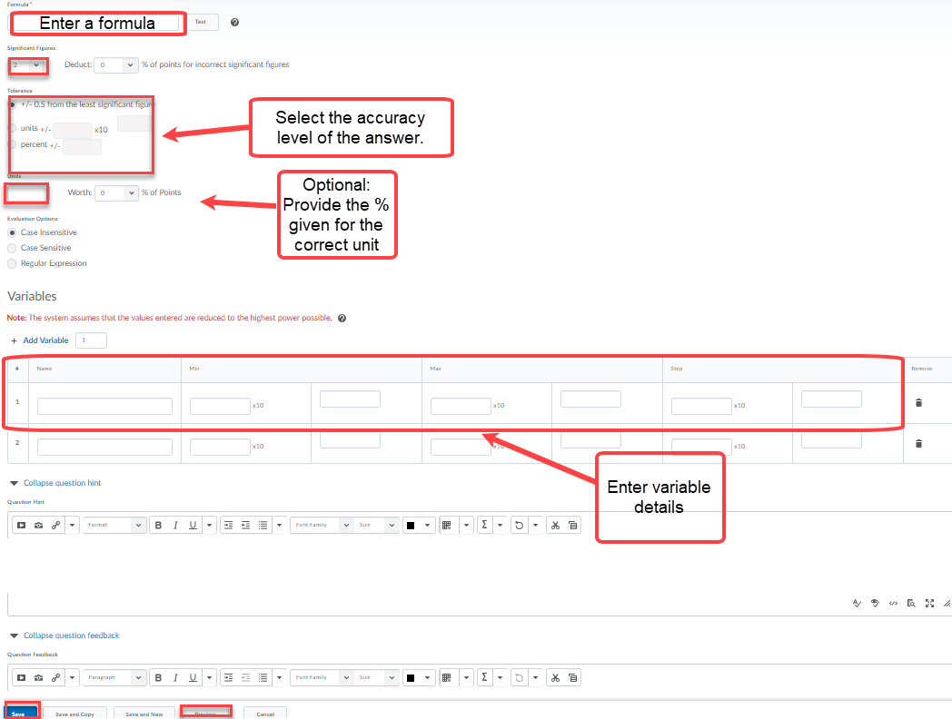
Likert Question (survey)
Under the Question Library, access the Likert Question by selecting the New Question button. This question measures subjective information (opinion, attitude, knowledge, abilities) and allows the user to rank the statements on a given scale.
Click Save (if you want to add other types of questions) or Save and Copy (create a new question with the current question as a template) or Save and New (to create another question of the same type).
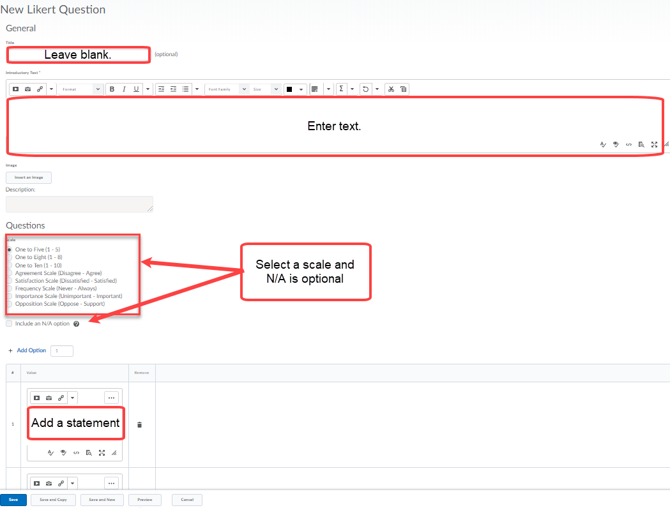

Editing Questions in the Question Library
To edit a question in a Question Library, first click on the folder to access the questions. Then, click on the drop-down menu next to the question to select Edit.
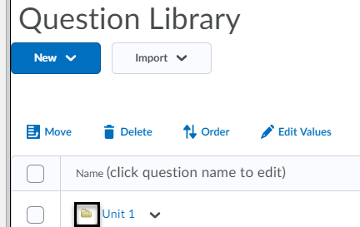
Click Save (if you want to add other types of questions) or Save and Copy (create a new question with the current question as a template) or Save and New (to create another question of the same type).

Creating Quizzes

To organize your quiz by sections, click on New and select Section from the drop-down menu. (If this step is done in the Question Library, use the import option to find the questions to insert in your quiz.)

Setting up a Quiz
Under Assessments > Quizzes, click on Manage Quizzes [1] and New Quiz [2]. Enter a name for your quiz [3]. Click on Add/Edit Questions [4]. Save and Close (return to main page) or Save (to remain on the same page) [5].

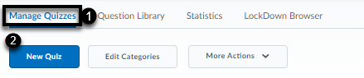
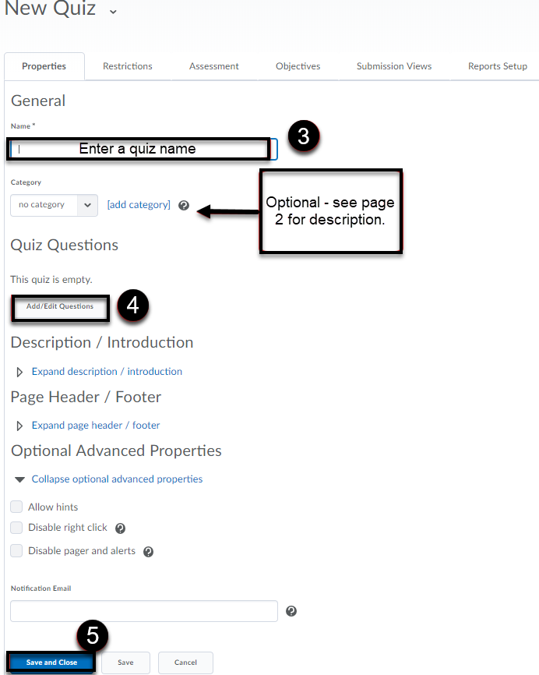
Note: It is possible to add a description of the quiz prior to availability as well as an introduction description at the start of the quiz. Enter text under the “Expand description/introduction link.”

Select the Add/Edit Questions option (under Properties Tab), you will be presented with the following options – Add or Import:
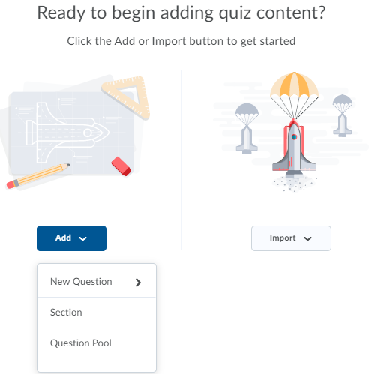

Note: It is possible to upload a CSV formatted file or Zip IMS QTI compliant course package or select questions located in the library by selecting Import. D2L accepts the import of files from Respondus 4.0.
Select Add > New Question to create new questions from 11 different question types. (Likert question is found under Question Library only).
Use Import button to upload existing questions. Click Browse Question Library to select the folder(s) or individual questions or upload a D2L formatted file. It is possible to search for and select questions in Question Library section by clicking the Source: drop-down menu. Filter by test question and sort by question type, points, and title. Click the Import button after you select the questions or section to import. Then, select the Back to Settings back button.

Other Import options:

It is possible to import a section (folder of questions) found in the question library into a quiz using Import drop-down menu > Import to Section.

It is possible to import a section (folder of questions) found in the question library into a quiz using Import drop-down menu > Import to Top of the Quiz or Import to Bottom of the Quiz.

Click the Import button after you select the questions or section to import. Then, select the Back to Settings back button.

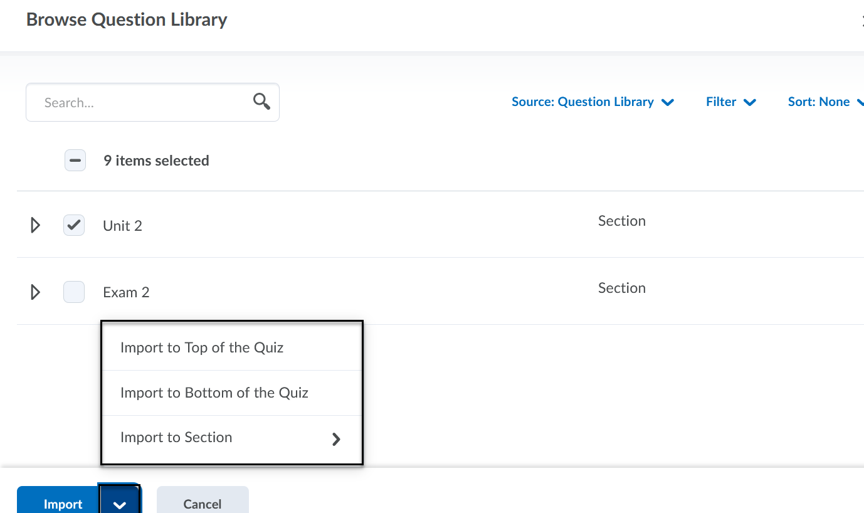
On the Edit page, access these tabs – Restrictions, Assessment, Submission Views, Reports Setup.
Once editing is complete, click Save and Close to return to the Quizzes Page.

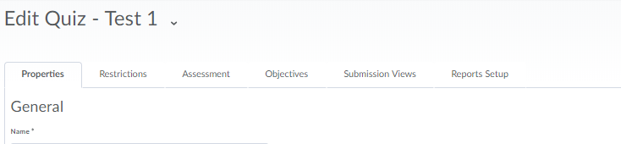

The Restrictions tab (see page 28) allows you to:
- Change your quiz status to Active. By default, quizzes are inactive - not available to students.
- Set a time limit for students to take the quiz.
- Manage late submissions.
- Assign special access to the quiz. For example, assign extra time to specific students.
The Assessment tab allows you to:
- Associate the quiz with a Grade Item in the Gradebook.
- Attach a rubric to the quiz.
- Manage the attempts (how many times students can take the quiz) and the Overall Grade Calculation (the grade that gets calculated based on the attempts allowed).
The Submission Views tab allows you to:
- Edit the default message students see when they submit the quiz by clicking on the link Default View.
- Choose what questions, if any, you want students to see when they submit their quiz. For example, you can show questions answered incorrectly or correctly.
- Add Additional View – Restrict date/time students have access to the quiz.
Reports Setup tab allows you to:
- Export a variety of quiz report types depending on question statistics or question details.
- Set up when to release the report and to whom.

Creating a Quiz with Randomized Questions from a Section in the Library
- Click on Quizzes on the Main Navigation Bar under Assessment tab.
- In the Manage Quizzes page, click on New Quiz on the top of the page.
- Enter a name for your quiz.
- If you wish, add a category for your quiz. (See page 2 for a description of categories).
- Click on Add/Edit Questions.
- Click on New and select Question Pool from the drop-down menu.
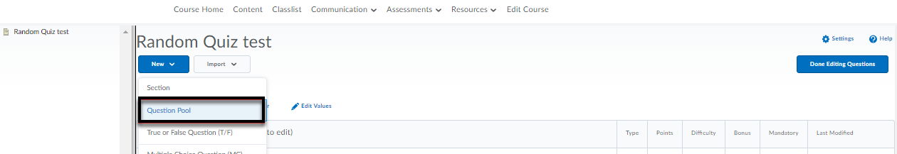
- Enter a title for the question pool, number of questions to select, browse question library to select section of questions and click Import. Enter points per question and Save.
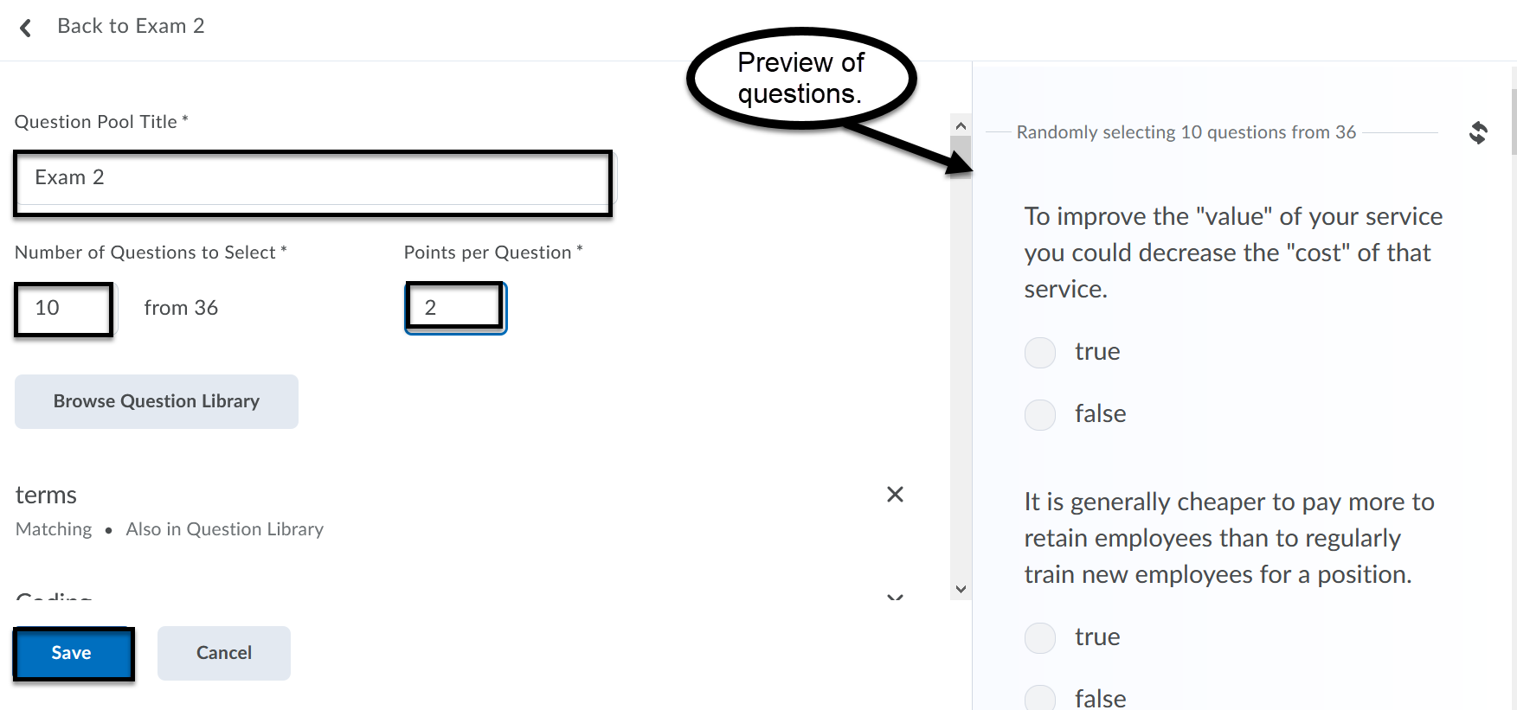
- To randomize questions at the quiz level, select Shuffle Questions at the quiz level. Other options include preventing students from moving backwards through pages. To set the number of questions per page, enter a number and click Apply. Click Save and Close. Preview the quiz to ensure the settings have been applied.
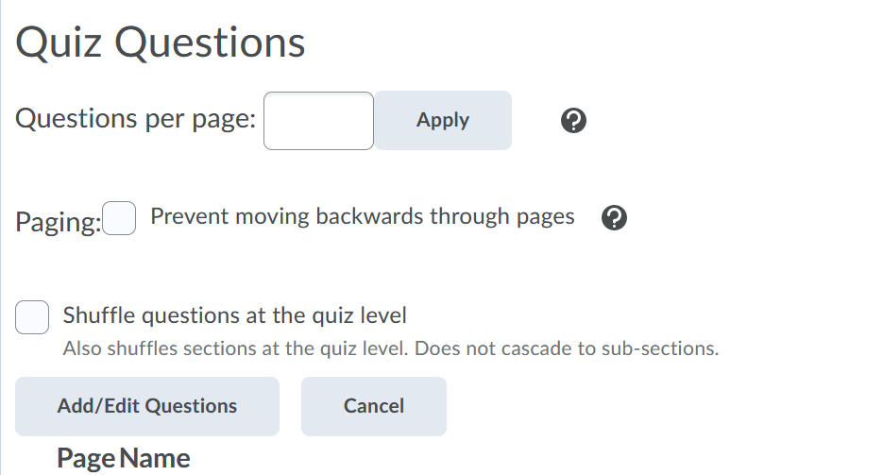
Restrictions Tab
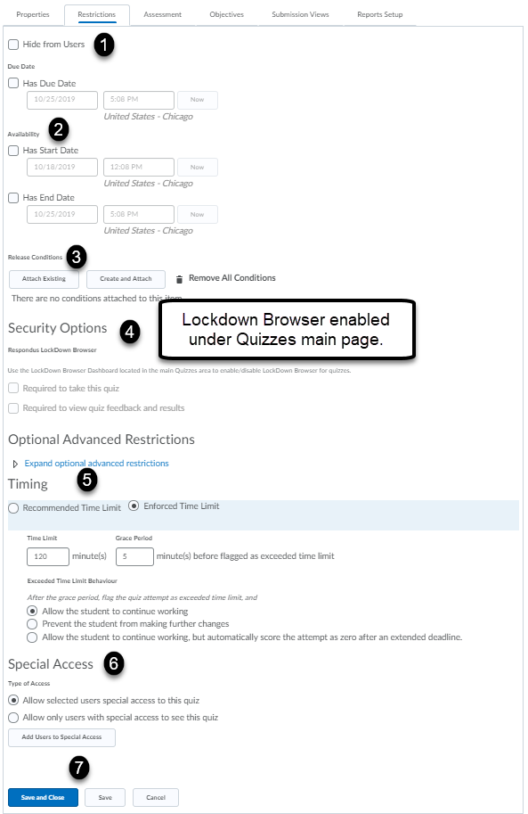
Check the Hide from Users box if you do not want the quiz visible to students [1]. Enter a due date and availability dates [2]. Release conditions is possible if you would like the student to complete a separate activity before the quiz is made available [3]. The LockDown Browser and Monitor can be enabled under the Quizzes main page. Once LockDown Browser is enabled under the Quizzes main page, the Required to take this quiz and Required to view quiz feedback and results options will be made available [4]. Enforced time with grace period is available [5]. Special Access is used to provide additional time or another quiz attempt for selected students.

Note: (Firefox is preferred browser): If you would like to enable LockDown Browser (which prevents the student from opening a new browser during testing), click the LockDown Browser tab under the Quizzes main page to Require Respondus LockDown only or Respondus LockDown and Monitor (which not only secures the student to test environment only, but records the student taking the test). Click Save and Close after reviewing the options under the Advanced Settings. For example, enable calculator on the toolbar is one of the options listed.

Mac Users: To access LockDown dashboard when using Safari: Click Safari menu > Preferences > Privacy button > Uncheck box for Prevent cross-site tracking.
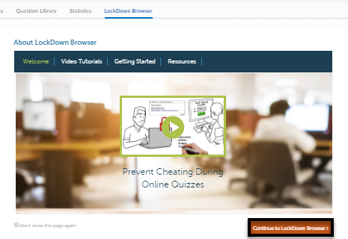
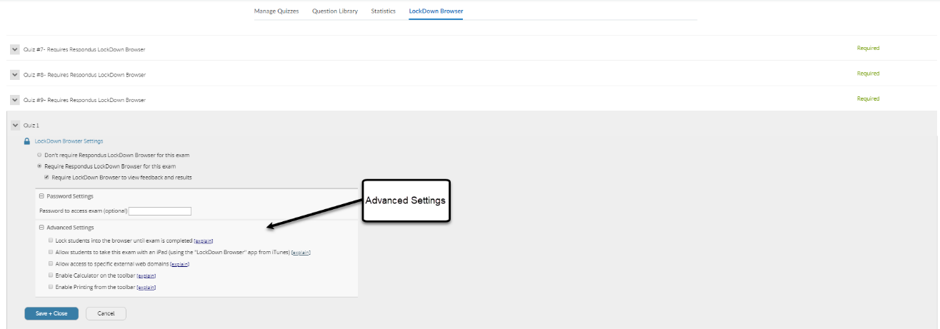

Assessment Tab

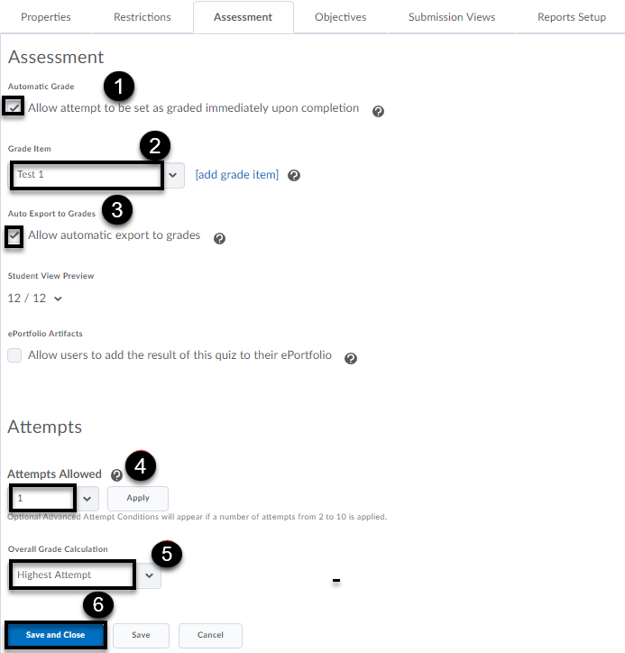
Students can see their score as soon as they submit their attempt. The score displayed is only what the system can auto-grade. This setting must be turned on for grades to be automatically sent to the grade book and the default submission view to be released to the students. [1]
Add grade item or associate to grade item in the grade book. [2]
When the Auto Export to Grades is enabled, the system can send auto-graded attempt scores to the grade book. Set attempts as marked in the Grade Quiz page to populate the grade book with scores if the Automatic Grade is not checked. [3]
Click the drop-down menu to select the number of attempts allowed. [4]
Click the drop-down menu to select the Overall Grade Calculation: Highest Attempt, Lowest Attempt, Average of all Attempts, First Attempt, Last Attempt. [5]
Save and Close to return to main page or Save to remain on the same page. [6]
Submission Views
The default view is what the student views immediately after submitting a quiz.
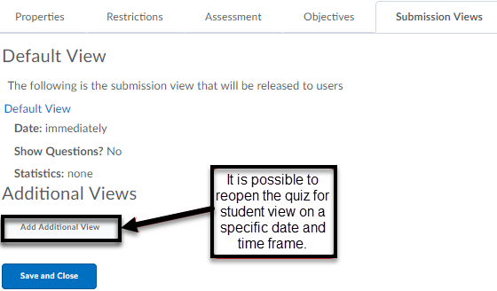
Default View:
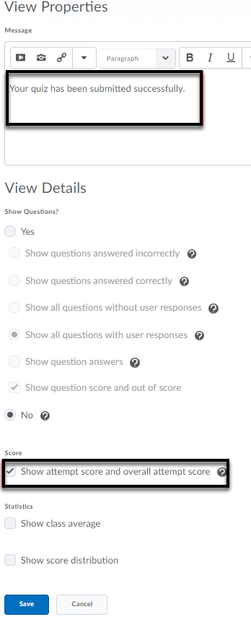
Reports Setup
If a report of question statistics, question details, users’ statistics, attempt details or user attempts is desired, then complete the Reports Setup by clicking Add Report. Choose the type of report and when and to whom to release the report.
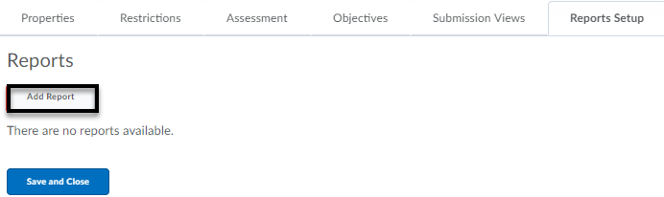
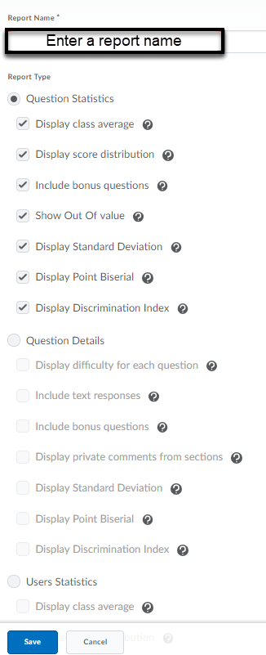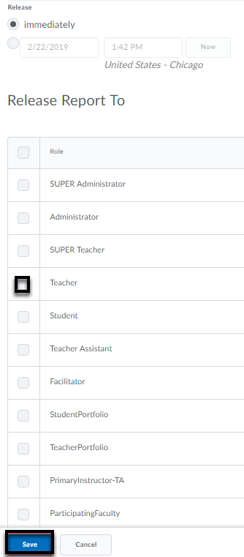

Editing and Deleting Quizzes

Editing Quizzes
- Click Quizzes from the Assessments (main navbar) drop-down menu.
- Click on the drop-down menu next to the name of the quiz you want to edit.
- Select Edit from the menu.
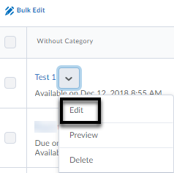
- Make your changes to the settings by using the tabs at the top of the page. Click on the Add/Edit Questions to add questions or to edit existing questions in the quiz. Click the checkbox whether to enable shuffling questions at the quiz level. Click the checkbox if you would like to prevent students from accessing previous questions. Save and Close to return to main page or Save to remain on the same page.
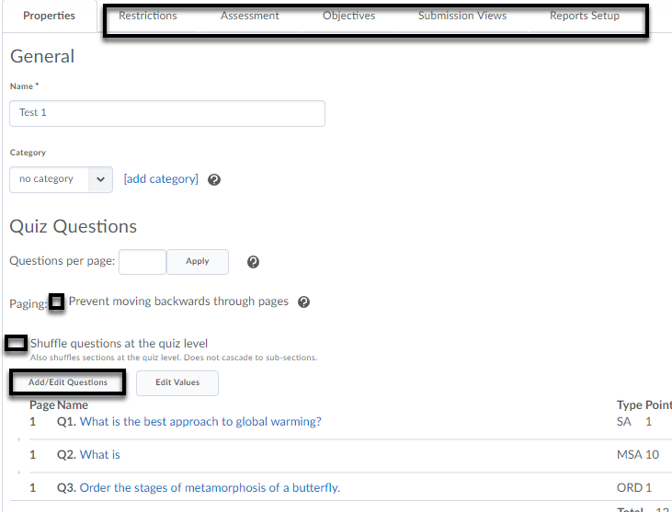
- If you would like to move questions to the top, bottom or a section in the quiz, select the checkbox(es) for those questions and select the drop-down menu for Move To.
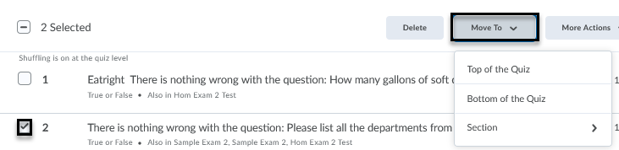
Deleting Quizzes
- Click Quizzes from the Assessments (main navbar) drop-down menu.
- Check the box next to the quiz you wish to delete.
- Click on More Actions at the top of the Quizzes Page and select Delete.
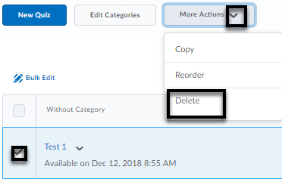
- Confirm the quiz deletion by clicking the Delete button.
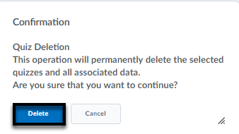

Moving Questions from a Quiz to Question Library
Select Question Library in Assessments > Quizzes.

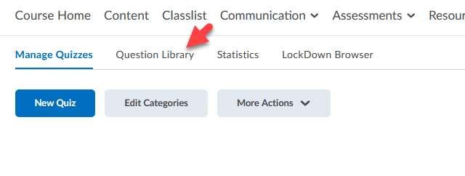

Click Import > Browse Existing Questions and find your quiz name in the drop-down list.

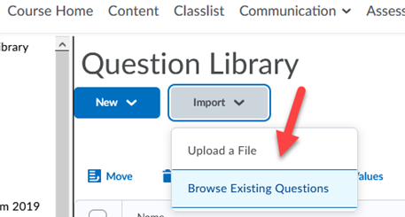

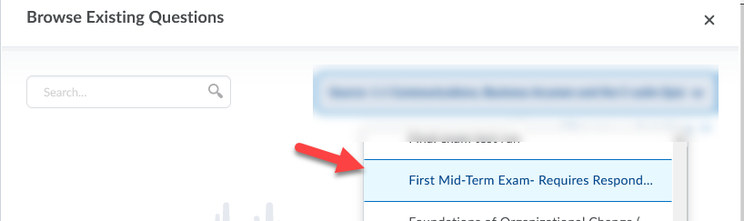

Check the checkbox for all items and select Add.

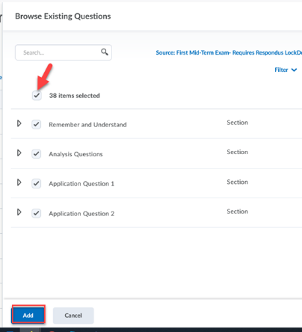

Grading Quizzes

- Go to Quizzes on the Main Navigation Bar.
- Click on the drop-down menu next to the name of the quiz you want to grade.
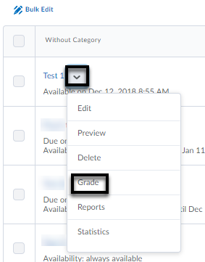
- Select Grade from the menu.
- This takes you to the Grade Quiz Page where you can filter submissions by student, attempts or questions.
- Click on the attempt link under the student’s name to grade it. The student’s entire quiz displays.
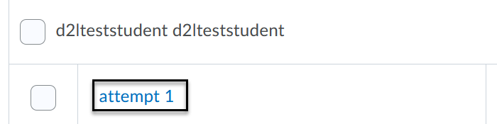
- Correct student answers appear as a green checkmark, incorrect answers appear as a red X with the correct answer marked with a blue arrow. Written responses (long answers) will need to be manually graded.
- You can provide feedback in two ways:
  - Individual feedback for a question: Click on the Expand question feedback link beneath the score box to type your feedback.
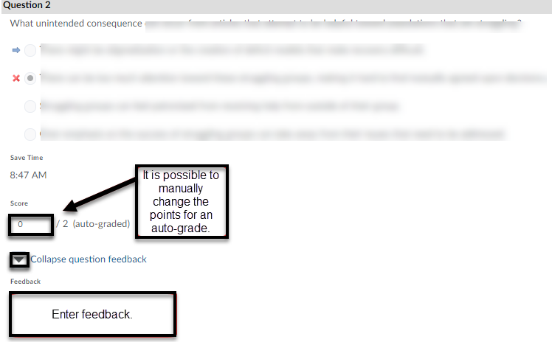

  - Overall Quiz Feedback: Type your feedback in the Attempt Feedback box and change the final score if desired.
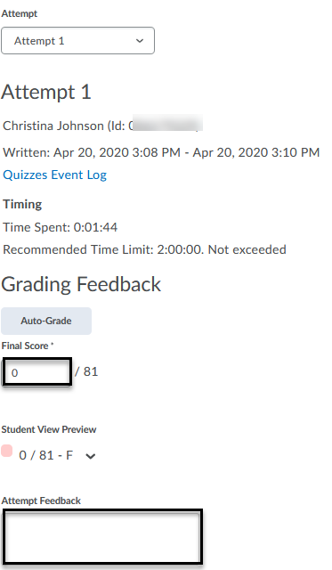

- After grading a quiz, click Save Draft and click the right arrow in the upper right-hand of the page to grade the next student.
- When you are done grading everyone, click Back button at the upper left-hand of the page to return to the quiz attempt listing.

- Click the Publish Feedback icon at the top of the quiz attempt list page to publish the quiz scores.

Grading an in-progress quiz
If you choose to grade a quiz with an in-progress status, you can use the Enter In-Progress Quiz as User permission to submit the quiz on the student’s behalf.
- Under Assessments > Quizzes, click Grade to access the students’ quiz attempts.
- Click the people icon next to (in progress).

- Click Yes to confirm you would enter the quiz as user.

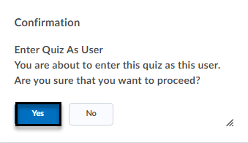

- Once in the quiz, click Submit Quiz.

Troubleshooting Tips for Quiz Scores not Publishing to grade book
Allow Export to Grades
- Check to ensure a grade item is associated to the quiz under Assessment tab of Edit page.
- A grade item needs to be selected to check Allow automatic export to grades.
- If there are questions that require manual grading, do not select Automatic Grade option (to allow attempt to be graded immediately upon completion).
- Click Save and Close.
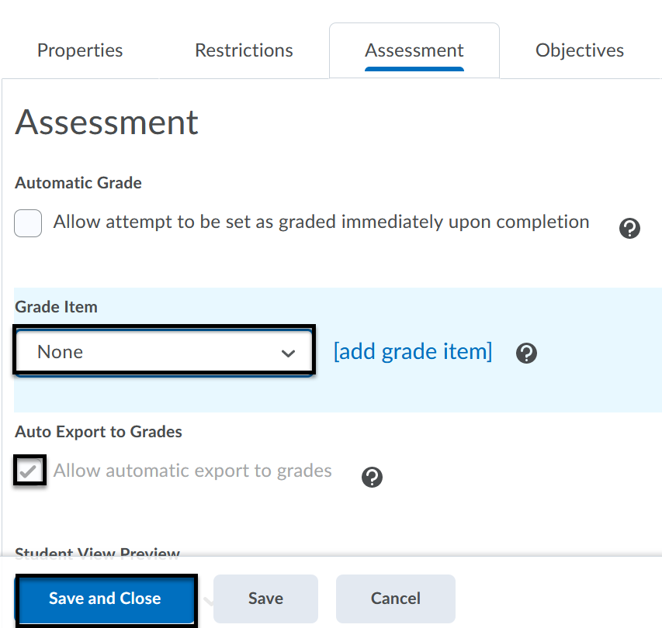
Publish Feedback
- Select Grade option of the Quiz drop-down menu to find the listing of the quiz attempt links.
- Ensure all student names are displayed by scrolling to the bottom of the page to ensure the number per page is set to 200 per page.
- Scroll to the top of the page to check the box next to First Name, Last Name to select all students in the list.
- Click Publish Feedback.
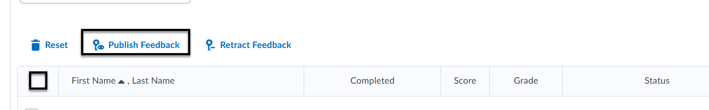

Anonymous Grading

Note: Once anonymous grading is enabled, visibility of student names cannot be modified after submissions exist.
- Under Assessments > Quizzes, click the drop-down menu next to the Quiz name to select Grade.
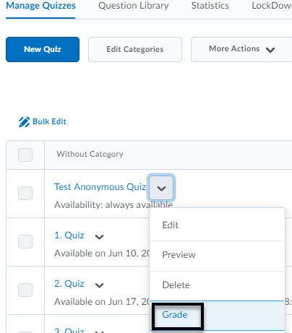

- Click on the Questions tab, to select Blind Marking [1] and click the first question to start grading [2].
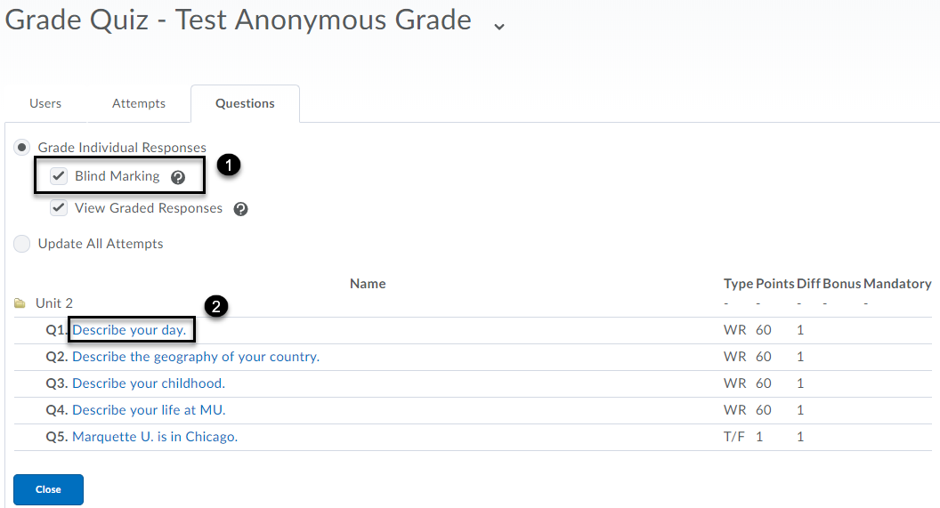

- Enter the score [1] and feedback [2]. Click Save and Continue [3]. Select the next student by clicking the number or arrow [4].
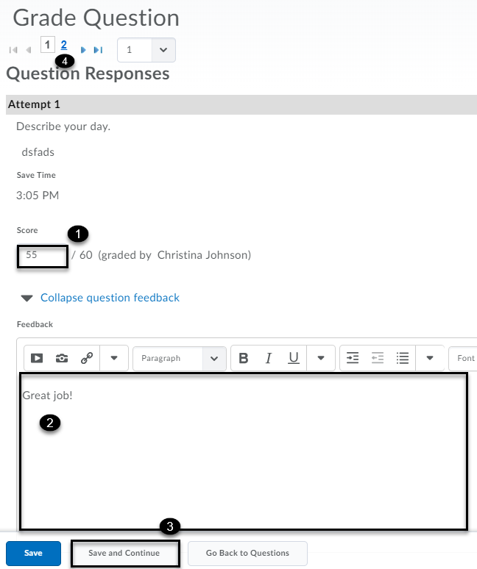
- Click Go Back to Questions to grade the next question.

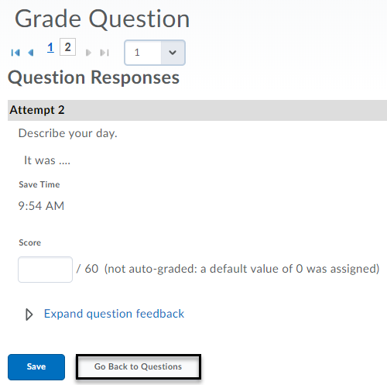

- To publish grades for all students to the gradebook, select the checkbox at the top to select all and click the publish icon. Click Save and Close.

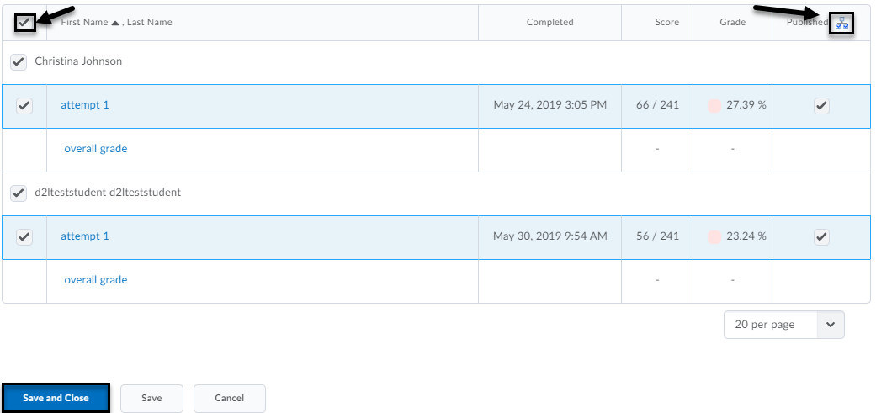

Reset or Restore a Quiz Attempt

Reset Quiz Attempt

A student is not able to resume a quiz that was started, but an instructor can reset the quiz attempt to allow the student to restart the quiz.

- Under Assessments > Quizzes > Manage Quizzes, select the drop-down menu next to the quiz name and select Grade.
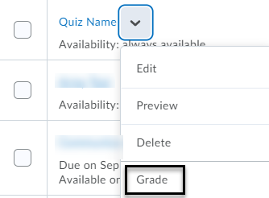
- Check the box next to the attempt you would like to reset and select the trash can icon (reset). Click Save and Close.

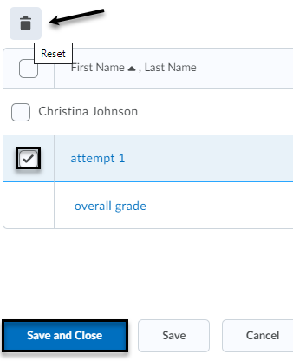

Restore Quiz Attempt

If a quiz attempt was deleted, the instructor can restore it by accessing the attempt log.

- Under Assessments > Quizzes > Manage Quizzes, select the drop-down menu next to the quiz name and select Attempt Logs.

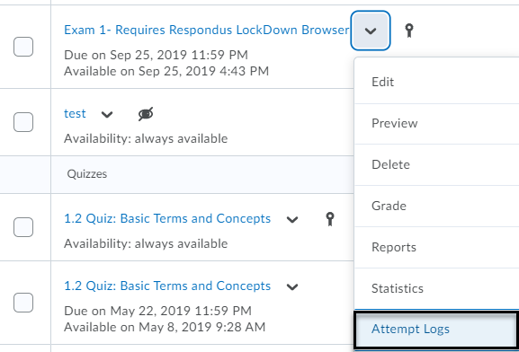

- Select the Restore button next to the attempt that was deleted in error.

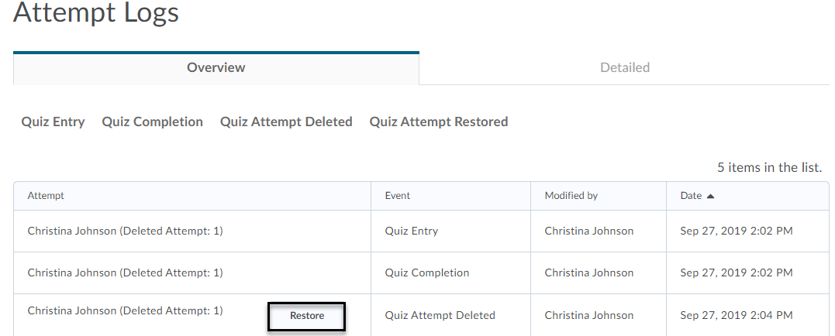

Regrade after updating a quiz attempt

If your quiz question was set up incorrectly after a quiz was submitted, D2L allows the ability to regrade the attempts. The instructor has the option to manually update each student’s quiz attempt or update all attempts at once.

Update individual quiz attempt

- Under Assessments > Quizzes > Manage Quizzes, click the drop-down menu next to the quiz name and select Grade.
- Click the attempt link to access the quiz results for each student. Enter the correct score for each quiz question accordingly.
- Click Save and Close.

Update all attempts
- Under Assessments > Quizzes > Manage Quizzes, click the drop-down menu next to the quiz name and select Grade.
- Select the Questions tab and select Update All Attempts radio button.
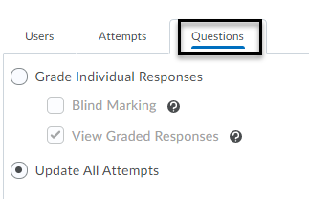
- Select the question that you plan to give points back to. By default, the grading type is set to Give to all attempts ( ) points. Otherwise, specify which answer requires the points. Enter the number of points in the text box along with an option to comment. Click Save.
- Modifications Log will date stamp the action at the bottom of the page.
- Click Go Back to Questions.
Note: Editing a quiz question after a student submits the quiz will not fix the student’s grades. A dialog box appears when an instructor attempts to edit a grade with student attempts. If you try to make an edit, another dialog box will inform you that those edits will only impact future attempts.
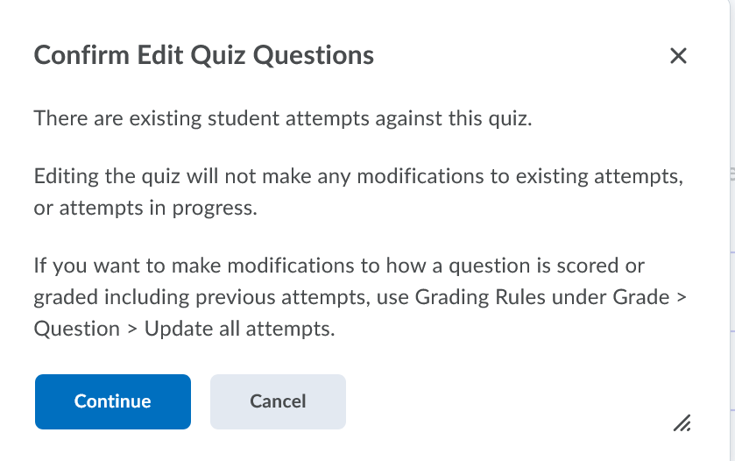
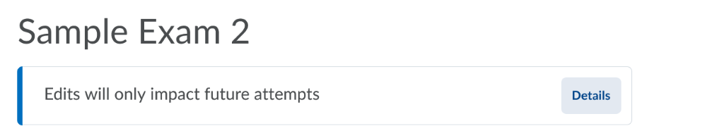

Retake Incorrect Questions Only

It is possible for students to retake a quiz or exam with only incorrect questions available to answer. When grading, the instructor can only provide a score for the questions answered on that attempt. Correctly answered questions add to the student’s score. The overall grade calculation (e.g., highest attempt, lowest, first, last and average) is applied. Average calculated grade allows for assigning partial credit for questions not answered correctly on the first attempt.
In order for students to be able to complete the subsequent attempts, the previous attempts must be published.
Retake Incorrect Questions setup:
- In Assessment tab of Edit Quiz page, first select the number of attempts under Attempts Allowed. This must be assigned as 2 or more for the checkbox to be available.
- Click Apply.
- Check the box for On new attempts, only allow answers for previously incorrect questions.
- Click Save and Close.
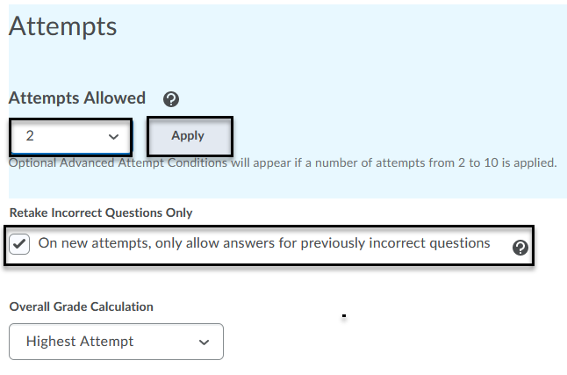
Note: If you are using Automatic grading, Written Response questions will be marked as 0 and included in future attempts until graded manually.

