D2L Discussions
Objectives:
- Create a discussion forum
- Create a topic in a discussion forum
- Edit forums and topics
- Delete discussion forums, topics, and threads
- Assess a topic

Contents
An Overview 2
Creating Discussion Forums 3
Creating Topics 6
Add a Topic through the Content Area 13
Viewing the Discussion Threads 14
To change from the Reading View to the Grid View: 15
Editing and Deleting Discussion Forums and Topics 18
Editing a Discussion Forum or Topic: 18
Deleting a Discussion Forum or Topic: 18
Deleting a Thread 19
Assessing Topics 20
Assigning an Assessment Method to a Topic 20
Steps to Assess a Topic 21

An Overview
Discussions are your course message boards, organized into forums and topics. Forums provide a collaborative space for student to student learning and for you and students to communicate asynchronously. This allows for engagement in higher-level thinking. Images and other media, such as YouTube videos, podcasts, and URL links can be posted with text.
Useful Terms:
Forums: Organize your discussion topics into categories. For example, enter Unit 1 for the title. There’s a checkbox to allow you to create a new topic in the forum with the same title. Students cannot post in a Forum unless you have created a Topic in it.
Topics: Discussions in a forum. For example, under Unit 1, you can have a Topic called Reading 1 and another Topic called Reading 2. Topics and can be set up as private or public.
Thread: Refers to a row of posts or comments under a Topic. Students click on New Thread when posting a response to your discussion prompt under the discussion topic.

Discussion List: Provides the options to add Forums and Topics. You can also view a list of all the existing Forums and Topics. This opens by default when the user clicks Discussions under the Communication navbar.

Subscriptions: Decide how you will receive notifications about activity in Forums and Topics. If you subscribe to a forum, you will see an alert show up in the minibar.
Group and Section Restrictions: View and edit all the restrictions to Forums and Topics for specific groups. It is recommended to create the group first and then associate the group to the discussion board under the Edit Topic Properties tab.
Statistics: Allows you to view and export students’ activity in discussion threads to a CSV file. You can view user statistics by individual or by groups and filter by users or topics. The topic statistics include total threads, total replies, pinned threads and unapproved posts. Forum statistics include total threads (all forums), total replies (all forums), pinned threads and unapproved posts.

Creating Discussion Forums

- Click the drop-down menu to select Discussions under Communication on the Main Navigation Bar. By default, the Discussion List page will open.
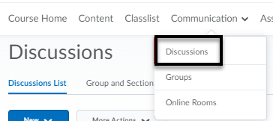

- Click on New and select New Forum from the drop-down menu.
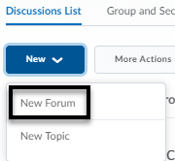
- On the New Forum page, enter the information and settings for the Forum using the Properties Tab (see page 4 for details).

Discussion Forum Properties Tab:
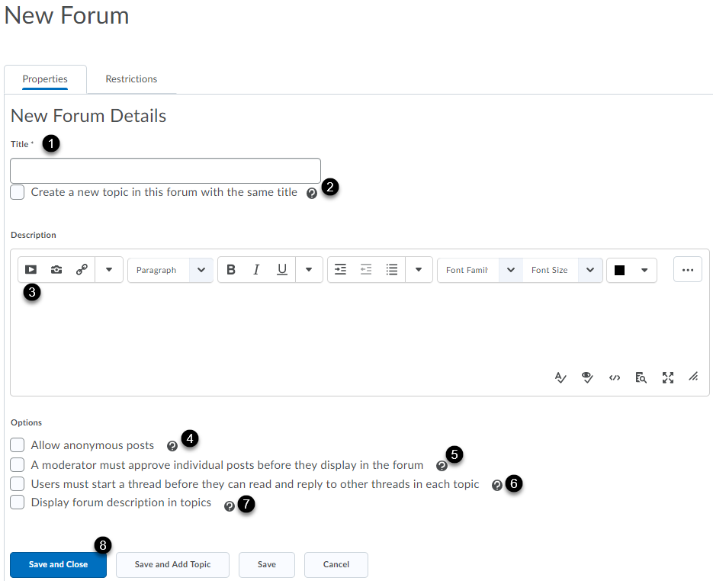
Enter a name for the forum title [1]. Automatically create a topic with the same name as the title [2]. Enter a description which will be visible from the Discussions List [3]. Anonymous posts cannot be evaluated [4]. Instructor must approve posts before they are public [5]. For an authentic response, enable Users must start a thread before they can read and reply to other threads in each topic [6]. Adds the forum description in topics [7]. Save and Close (saves and returns to Discussions page), Save and Add Topic (saves and opens New Topic page), Save (saves and user remains on the same page) [8].
- The Restrictions tab allows you to establish Release Conditions for the Forum. A student must complete a task in D2L before having access to the Forum. Under the Group and Section Restrictions you can also decide who in your class has access to this Forum. For example, if you have students working in groups and you want only members of that group working on this Forum to have access to it.
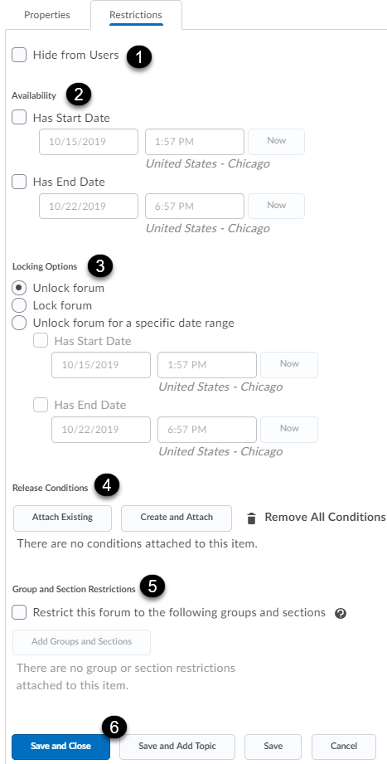
By default, the forum is always visible. However, you can hide the discussion by clicking the Hide from Users checkbox [1]. The availability allows you to hide the forum during a specific time period [2]. Locking option allows you to lock the forum for a specific time period [3]. By default, the forum is always unlocked. Manage release conditions [4]. Give access to specific groups or sections [5]. Save and Close (saves and returns to Discussions page), Save and Add Topic (saves and opens New Topic page), Save (saves and user remains on the same page) [6].

- Save your settings. If you’re ready to create a Topic under this Forum, click on Save and Add Topic.

Creating Topics

- Click the drop-down menu to select Discussions under Communication on the Main Navigation Bar. By default, the Discussion List page will open.

- Click on New and select New Topic from the drop-down menu.
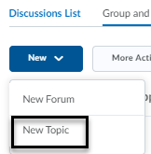

- Under the Properties tab of the New Topic page, enter the general settings for the Topic. See page 7 for details.

New Topic Properties Tab:
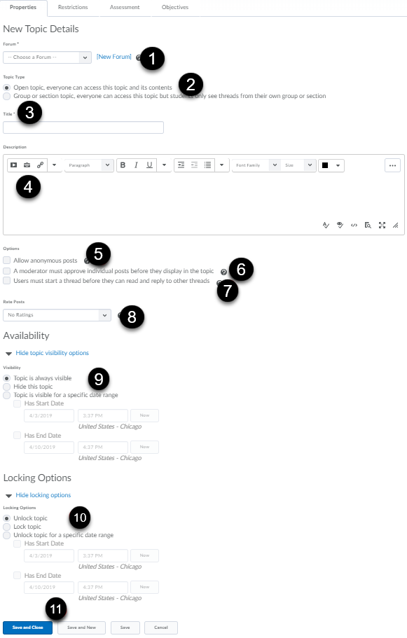
Click the drop-down menu to select the forum that was previously created. If one was not created, click [New Forum] [1]. By default, the topic is open to everyone. Select the second radio button, if the topic is restricted to a specific group or section [2]. Enter a topic title [3]. Enter a description for the topic [4]. Under Options, if you select allow anonymous posts, you will not be able to grade the discussion board. The author of the post will display as “Anonymous” [5]. A moderator must approve posts in this topic before they display to users [6]. The student is required to post in the topic before viewing or replying to other students [7]. It is optional to rate posts in three different ways: Five-Star (allows user to assign each post a score out of 5), Up Vote/Down Vote (allows user to move posts up or down in rank), Up Vote Only (allows user to move up posts up in rank). By default, the setting is No Ratings which hides all rating controls from the student. The topic always remains visible, by default [8]. It is possible to change the visibility start and end dates [9]. By default, the topic remains unlocked. If the topic is locked during a specific time range, the students will not be able to access the discussion board until it is unlocked [10]. Save and Close (saves and returns the user to the Discussions page), Save and New (saves and creates a new topic) and Save (saves and user remains on the same page) [11].
Restrictions Tab: Attach existing or create and attach conditions which allows you to establish Release Conditions for the Topic. That is, a student must complete a task in D2L, such as completing a quiz, before having access to the Topic. Under the Group and Section Restrictions you can also decide who in your class has access to this Topic. Save your changes.
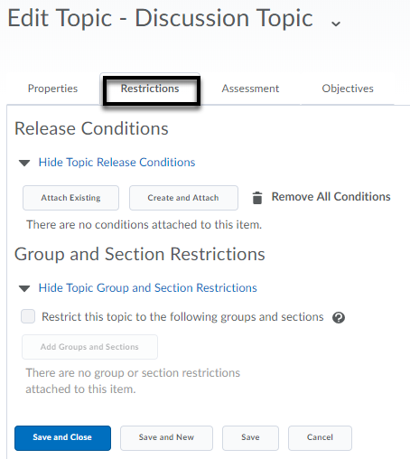

Assessment: Allows you to associate the discussion Topic with a Grade Item (must be already created), assign a score, and add a rubric (optional). You can also assess individual posts in the Topic by selecting a calculation method from the drop-down list (optional). Check the box if you would like to include unassessed individual posts in the calculated topic score as zero. If this is not selected, the unassessed individual posts will not be included in the topic score calculation. Pages 20-21 provide detailed descriptions of the calculation methods. Save your changes.
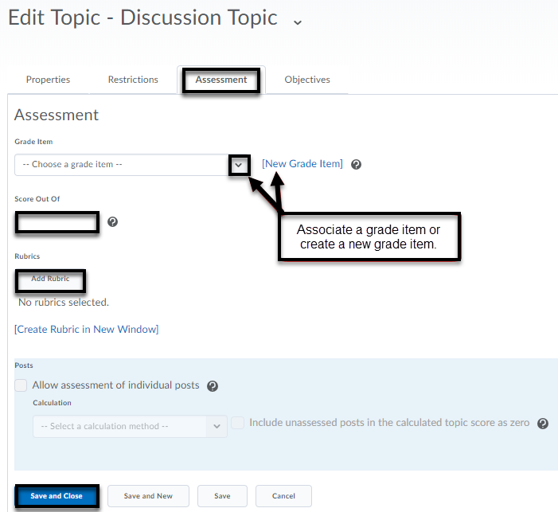
Objectives: Allows you to associate learning objectives with the topic. (Optional)
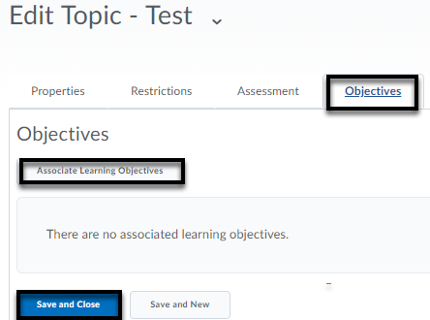
Note: The learning objectives must be created first under Assessments > Competencies and New > Learning Objective for a listing to appear when you are ready to associate. Also, a learning competency structure will need to be created for the objective. (Select Competency under Competency Home page).
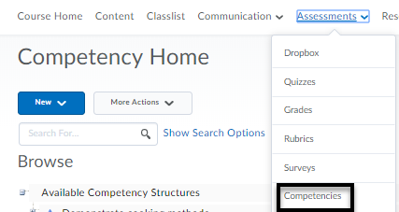
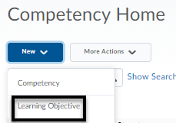
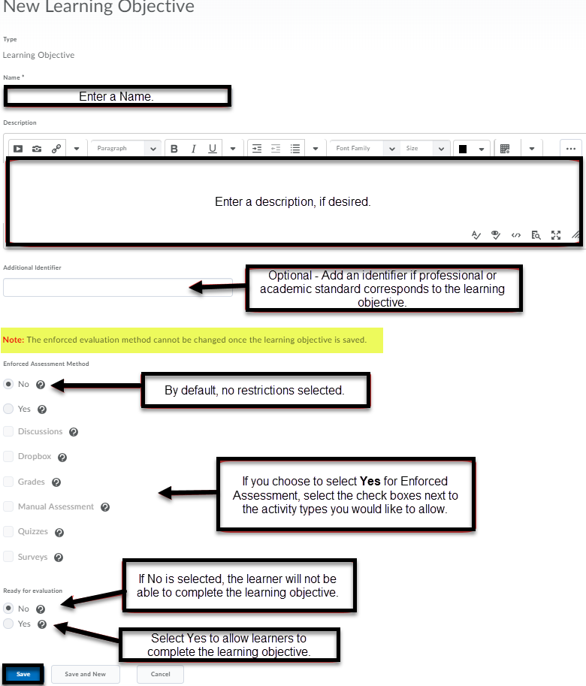
Once the Competency is created, it can be associated with its children (learning objectives). Check the boxes for making the competency and its children visible to learners and allowing re-evaluation of learners who have achieved the competency. Click Save or Save and New (to save and create a new competency).
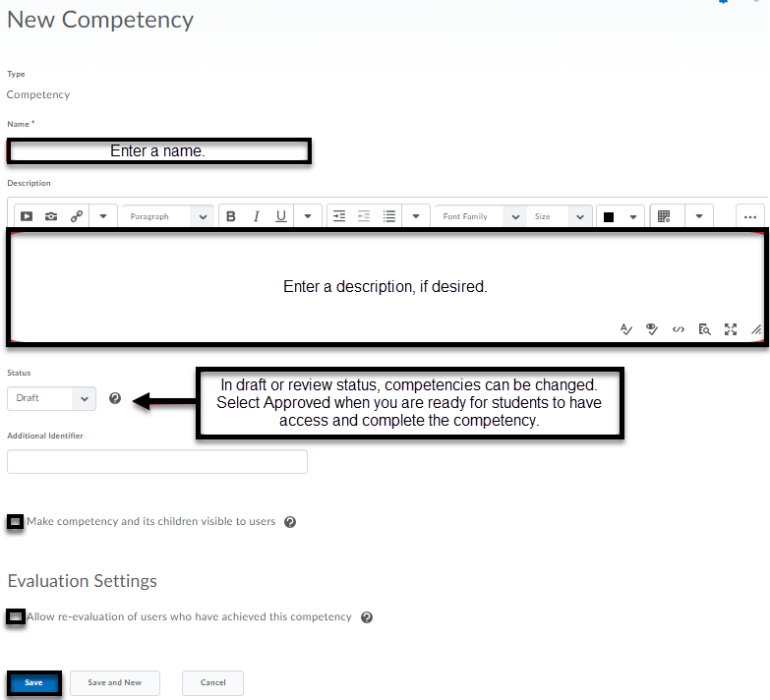

Add a Topic through the Content Area
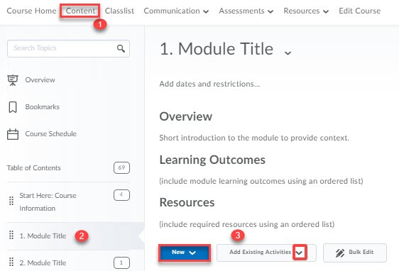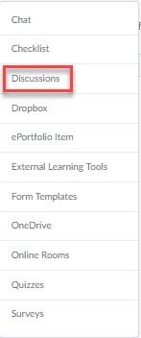

Click on Content in the Main Navigation Bar [1]. Click on the module where you would like to add your discussion Topic [2]. Click on the New button and select New Discussion from the drop-down menu or select Add Existing Activities and select Discussions [3].
If you selected New Discussion, you will be directed to a new page to create the discussion topic and forum. Click on Save.

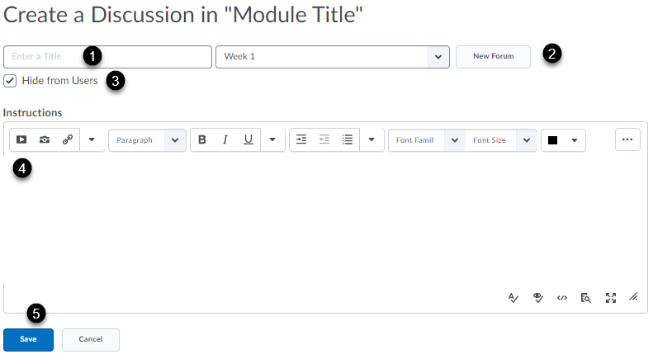

Enter a title for the Discussion [1]. If no forums exist, create a new forum for the topic [2]. Deselect the box if you would like the discussion board visible to students [3]. Enter a discussion prompt and other instructions [4]. Click Save. Dates and restrictions and grade item can then be added under Activity Details.

Viewing the Discussion Threads

D2L now offers two viewing options when you’re looking at your students’ posts in a topic:
Reading View: It’s the default viewing option. Messages display individually.
Grid View: Posts and replies are displayed in form of a list (i.e., thread) in a topic. The Printable view is available when you use the Grid View.
Note: Students also have the option to change the view, if they wish to do so.
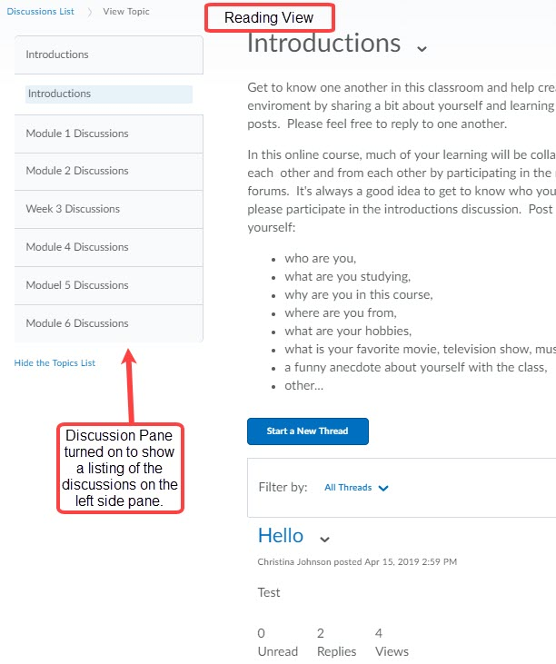
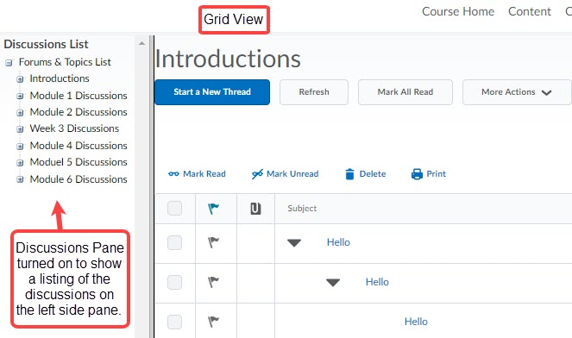

To change from the Reading View to the Grid View:
      - Click on the Communication tool on the Main Navigation Bar.

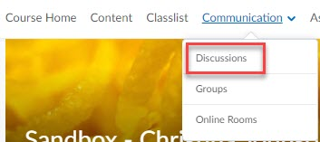

      - Click on Settings on the right-hand side of the screen.
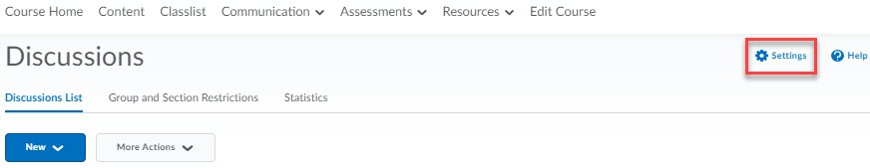

      - Select Grid View radio button under Default View and click Save. Note the descriptions of the selections are on page 17.
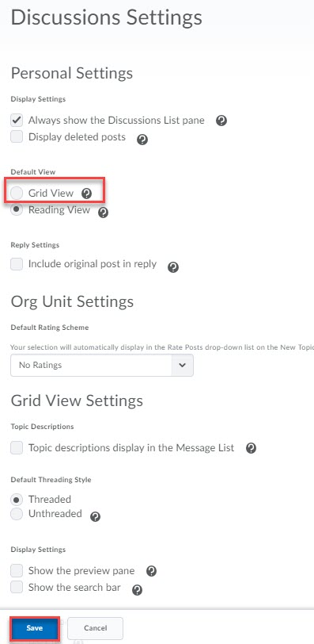
Deleted posts show up in gray and crossed out the Message List.
A list of all the discussion forums and topics appears on the left-hand side of your screen.

      - Scroll down the page to edit the Grid View Settings. Note: No matter which view you select in your settings, you can toggle between the views using the drop-down list.

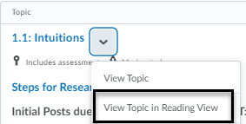

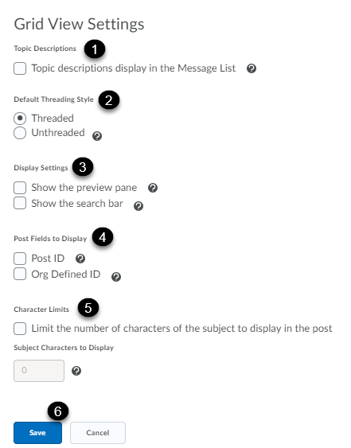

Check to display a topic’s description in the Message List (the list of posts under that topic) (optional) [1]. Threaded posts are grouped together with their replies in the Message List. Unthreaded posts are sorted by author, date, or subject [2]. Show the preview pane allows the user to open all posts in a preview pane or clear it to open all posts in pop-up windows. This splits the screen showing the Message List on the top and the selected post at the bottom. Show the search bar option displays a search bar to search for posts (optional) [3]. Check to display the Post ID with the Message List or Org Defined ID to display the students’ MU ID on the Message List (optional) [4]. Character Limit allows you to display a limited number of characters of each post’s subject to save screen space. Enter the maximum subject characters to display (optional) [5]. Click Save after making your selections [6].

Editing and Deleting Discussion Forums and Topics

Editing a Discussion Forum or Topic:
- Click on Discussions on the Main Navigation Bar.
- Discussions List opens by default.
- Click on the drop-down menu next to the name of the Forum or the Topic.
- Select Edit Topic or Edit Forum (depending on which one you’re editing).
Edit Topic Edit Forum
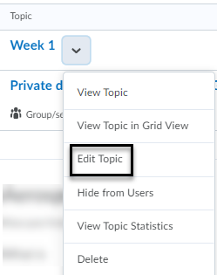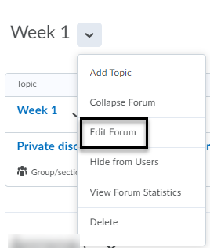
- Once you’re done editing, click on Save and Close.

Deleting a Discussion Forum or Topic:
- Click on Discussions on the Main Navigation Bar.
- Discussions List opens by default.
- Click on the arrow next to the name of the Forum or the Topic.
- Select Delete.
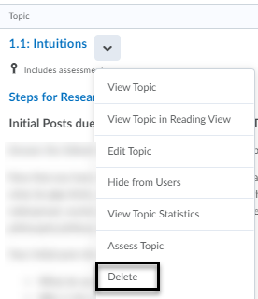

Deleting a Thread
- Click on Discussions on the Main Navigation Bar.
- Discussions List opens by default.
- Click on the Topic where the Thread you want to delete is located.
- Click on the downward facing arrow next to the name of the Thread you want to delete.
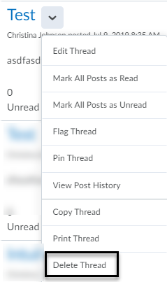
- Select Delete Thread from the dropdown menu.
*Note: When you delete a Thread, the system also deletes any replies to that Thread. The same happens if you delete a Post within a Thread.

Assessing Topics

Assigning an Assessment Method to a Topic
- Click on Discussions on the Main Navigation Bar.
- Discussions List opens by default.
- Click on the arrow next to the name of the Topic and select Edit Topic.
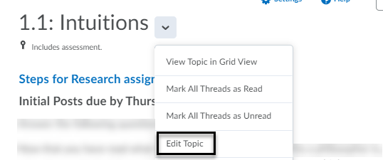
- Click on the Assessment tab on the top of the Edit Topic page.
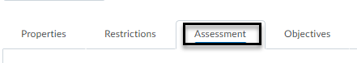
- Select the assessment method you want to use:
  - Associate the discussion Topic with a Grade Item.
  - Assign a score to the Discussion Topic.
  - Add a rubric. (If you decide to use this method, it is not necessary to check Allow assessment of individual posts). Assessing with a rubric will automatically populate the topic score.
  - Various calculation methods are available to assess individual posts (optional):
    - Average post score: Averages all of the post scores included per student.
    - Maximum post score: Identifies the highest score of all the post scores included per student.
    - Minimum post score: Identifies the lowest score of all the post scores included per student.
    - Mode post score - Highest on multiple: Looks at the frequency of scores on posts, then selects the highest occurrence of a score per student. Once it picks the frequency, the system looks to see if multiple scores occur at that frequency. If not, it assigns that score to the user. If there are multiple scores with the same frequency, it will choose the highest of those scores. For example, if a score of 7 occurs 2 times, a score of 8 occurs 3 times, and a score of 9 occurs 3 times, the system will choose the frequency 3 and the score of 9.
    - Mode post score - Lowest on multiple: Looks at the frequency of scores on posts, then selects the highest occurrence of a score per student. Once it picks the frequency, the system looks to see if multiple scores occur at that frequency. If not, it assigns that score to the user. If there are multiple scores with the same frequency, it will choose the lowest of those scores. For example, if a score of 7 occurs 2 times, a score of 8 occurs 3 times, and a score of 9 occurs 3 times, the system will choose the frequency 3 and the score of 8.
    - Sum of post scores – Sums up all the scores on posts within a topic.
    - Include unassessed posts in the calculated topic score as zero – Check this box only if you want unassessed posts included in the topic score.

- Click Save and Close at the bottom of the page.

*Note: When you add an Assessment to a Topic, the option Assess Topic will be added to the dropdown menu.

Steps to Assess a Topic
- Click on Discussions on the Main Navigation Bar.
- Discussions List opens by default.
- Click on the arrow next to the name of the Topic and select Assess Topic.
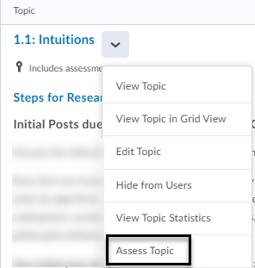
*Note: If you enabled a moderator must approve individual posts, then select Approve Threads before assessing student via Assess Topic.
- Click on Topic Score beneath each user’s name. This opens a window where you can see the student’s posts under that topic (below rubric and general feedback).
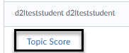
- Assign a score and add any written feedback.

- Check the box next to Publish to export grade automatically to the Gradebook. *Note: The Grade Item must have been created and linked to the Topic already for the Publish option to work.
- Click Save.
*Note: You can choose Publish after scoring each user or you can click on the Publish All Feedback after you’re done scoring all the users. It’s best practice to publish after grading all students.
