Revision Date: April 18, 2018

Copying Materials from a

Previous Course
Objective:
- Copy Materials from a past course to a current course

D2L allows you to copy all the content or some of the content from previous courses. User (student) data is not copied. For example, if you copy the discussions component, only the forums and topics will be copied, not the messages posted to topics. Similarly, if you copy quizzes, student attempts will not be copied, etc.

- Go to the D2L course that you wish to copy the information to.
- Click on Edit Course on the right-hand side of the screen.
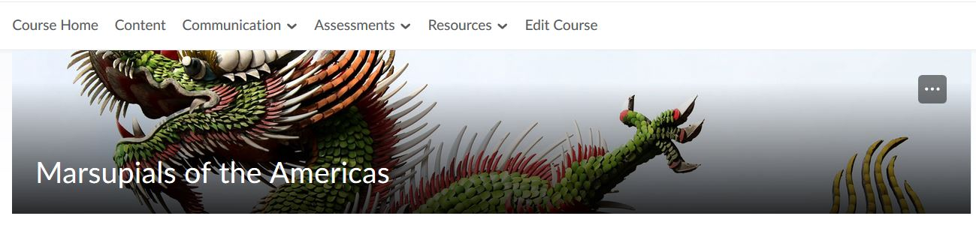

- Click on Import/Export/Copy Components.
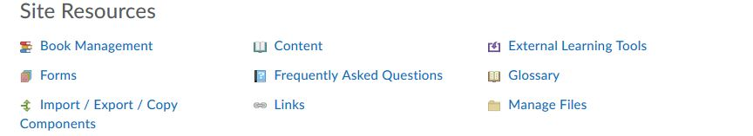

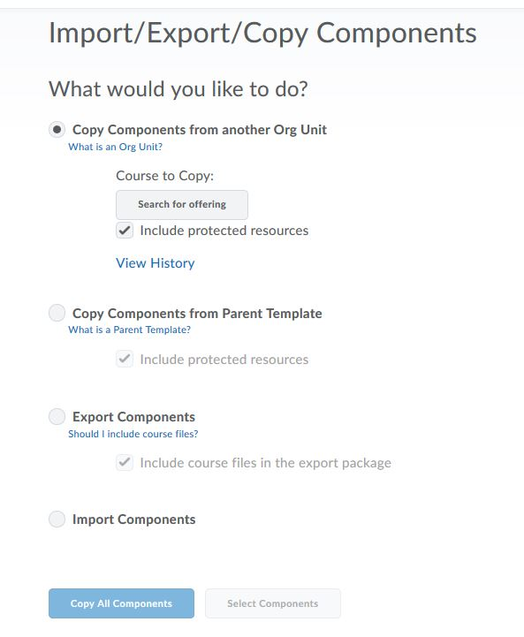
- The next page gives you the option to copy, import, or export. The default is to copy, so just click in Search for offering to select your course.

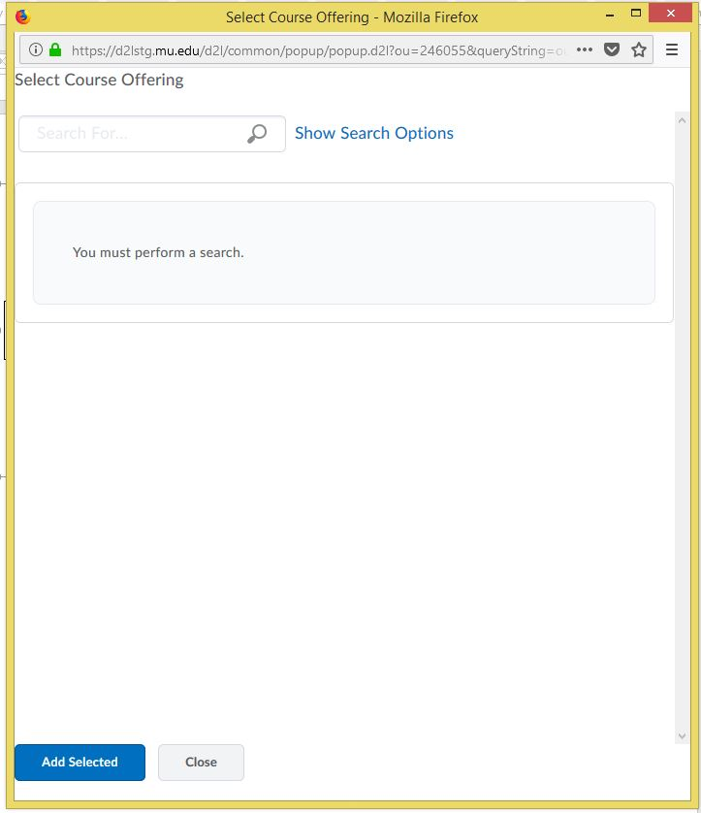
- A dialogue box opens with a search field. Enter the name of the course (e.g., PRST 1001) in and click on the magnifying glass icon to search.
Write course name here.
Click here to search for the course.

- Select the course from the list. Make sure you select the correct semester.

- Click on Add Selected.

- To copy all the content from the previous course: select Copy All Components at the bottom of the page. You will be taken to a page that shows you the pace of completion. A green checkmark will indicate you’re all done.

- To copy certain information only from the previous course, click on Select Components. You will now see checkboxes for the components that are available to copy. Select the components you want to copy by selecting the checkbox next to each component. To copy only certain items from a component, choose Select individual items to copy. This allows you to select, for example, individual quizzes, discussion forums, dropbox folders, etc.

NOTE: If you wish to copy the content from one course to another you must copy both the content and the course files. The content is the format of the content page, whereas the course files are the actual files associated with the content page.

