Creating or Converting .pdf Documents Overview

Objectives:
- Determine if copyright complaint
- Identify software requirements to edit .pdf files
- Convert an accessible Word document to a .pdf file and make it accessible
- Check accessibility of a .pdf document and make it accessible

Contents

Creating or Converting .pdf Documents to Accessible Documents 1
Getting Started 2
Overview: 2
Useful Terms: 2
Decision Matrix: 3
Copyright compliant? 4
.pdf files from Raynor Library or another electronic source 4
Word to .pdf? 6
Converting a Word document to .pdf 6
Accessible Review: 6
Create a .pdf: 6
Edit the .pdf file to accessible: 8
Editing Failed issues: 9
Manually Editing Failed Issues and Need Manual Review Issues: 11
.pdf to Accessible Format 14
Converting a .pdf to Accessible Format: 14

Getting Started

Overview:
There are many resources available to faculty and staff that will enhance the learning experience for the student. This workshop/document address document files that are saved in .pdf format.
The first step is to determine if the .pdf file meets MU’s copyright policies. After that, the faculty member will determine if it is best to offer the content in .pdf format or MS Word (Word) format. Both formats require that the content is accessible.

Useful Terms:
Accessibility Checklist: This document was created by Marquette’s Accessibility Committee and is designed to be the University standard for which all courses and course content are to be designed.
Adobe Acrobat DC Pro: This software has unique functionality in that it will convert a MS Word document to .pdf or it will convert a .pdf to a Word document. Note that even though the conversions do a lot of the work, neither conversion is complete. More work is required to both documents before they meet the requirements listed in MU’s Accessibility Checklist.
Copyright: Marquette’s Copyright Policy is well documented and therefore, it is not reviewed in detail as part of this document. However, the document discusses copyright as it applies to images, video and website links. There are a few resources that you may want to visit to refresh you understanding of copyrights, Marquette’s Copyright Statement of compliance, Marquette Copyright Training, General principles of Fair Use in Education policies, Know Your Copyrights and Can I Use it? map.
.pdf file: A Portable Document Format (PDF) is a file that is created or saved using Adobe Acrobat. It is a file format that is used universally among various software, hardware or operating systems.

Decision Matrix:

Copyright compliant?

.pdf files from Raynor Library or another electronic source
It is assumed that if you created a document, using MS Office and saved that document as a .pdf that you are the owner and that you understand the copyrights for your document.

For documents that you did not create, the first question at hand is to determine whether the .pdf is copyright compliant. Refer to Raynor Library’s Copyright website for specific information.

There is no one answer to the question: Can Raynor’s e-resources be used in D2L? The answer to this question is dependent on the licensing agreement that Marquette has with the owner and several other factors. You may also contact one of Raynor’s librarians to discuss the copyright and fair use regarding a specific document or article.

Helpful Hints:
- Refer to Marquette’s Appropriate Use of Course Materials/Fair Use section regarding posting digital course content.
- If you are using resources from Raynor, look for a “Durable Link” option. Those links can be embedded in D2L. From Raynor’s Main Menu, select Research Help. From the dropdown menu, select Research Guides.
Research guides.
Research Help.

- Scroll to the Durable Links option and click to open the page. On the left side of the page, you will see a list of databases. Each database includes instructions to locate the Durable Link (AKA URL, Permalink, etc.)
- Most websites indicate ownership of the documents shared on their website. You may find that the website has a copyright statement where the document is free to use and share. Or you may be able to contact the owner and request permission.
- Search for your article on a Creative Commons website such as MIT: ocw.mit.edu, Rice: cnx.org or Merlot: merlot.org.
- If you are planning to use a document from Raynor Library and it does not have a Durable Link option and you are not sure if it is copyright or fair use compliant, you may:
  - Use the Raynor’s Accessibility Database descriptions to determine if you document is offered in accessible format.
  - Consult Raynor’s Copyright website to learn more about Marquette’s copyright policies.
  - Seek assistance from a librarian.

Word to .pdf

If you own the document, it is a best practice to edit and use the Word document in accessible format. However, if the Word document is a large file, you may want to convert it to a .pdf file format.

Converting a Word document to .pdf
Accessible Review: It is assumed that your Word document is copyright and accessible, prior to converting it to a .pdf file.
- Review MU’s Accessibility Checklist to verify that your document is in accessible format.
- If you find format that requires editing, use the MS Word Accessibility on-line instructions for specific instructions.
Create a .pdf: You must have Adobe Acrobat Pro on the computer you are using to perform the next steps. Even though your Word document was accessible, you still need to perform additional steps to make the .pdf accessible.
- Using Word, select the menu option File, then select the option Save as Adobe PDF.
Select Save as Adobe PDF.

- A new window opens where you may edit the name your file and save.

Select Save.
Edit the name of your file.
- The new .pdf file will open in a new window. Notice that Adobe opens with a menu of Tools on the right of the screen. Additionally, you may use the main menu option to view and add Tools to the menu on the right. For this exercise, you will need the Accessibility Tools.
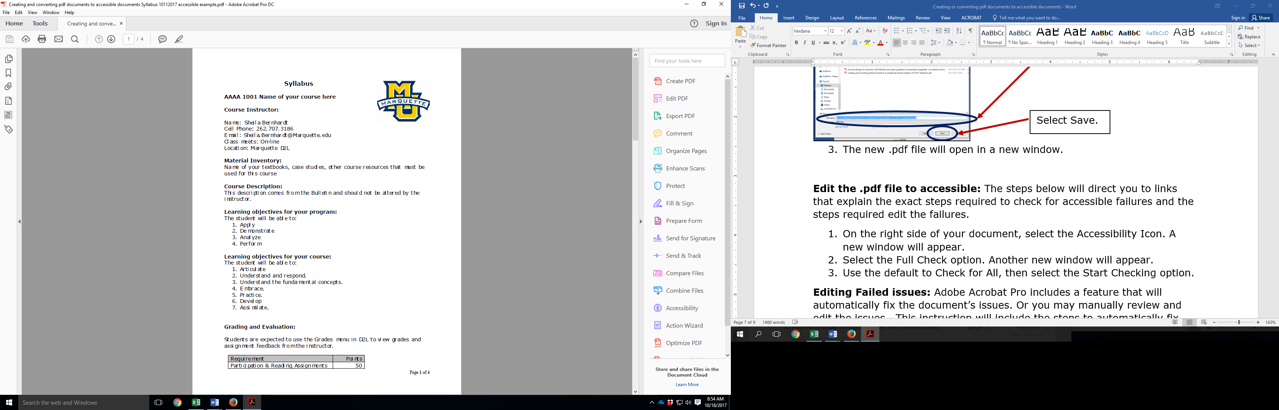
Accessibility Tool.
- If you do not see an Accessibility Tool, select Tools from the main menu.
Select Tools.

- Find the Accessibility Icon, click on the word Add next to the drop down arrow. You will see that the Accessibility Icon appears on the right menu.
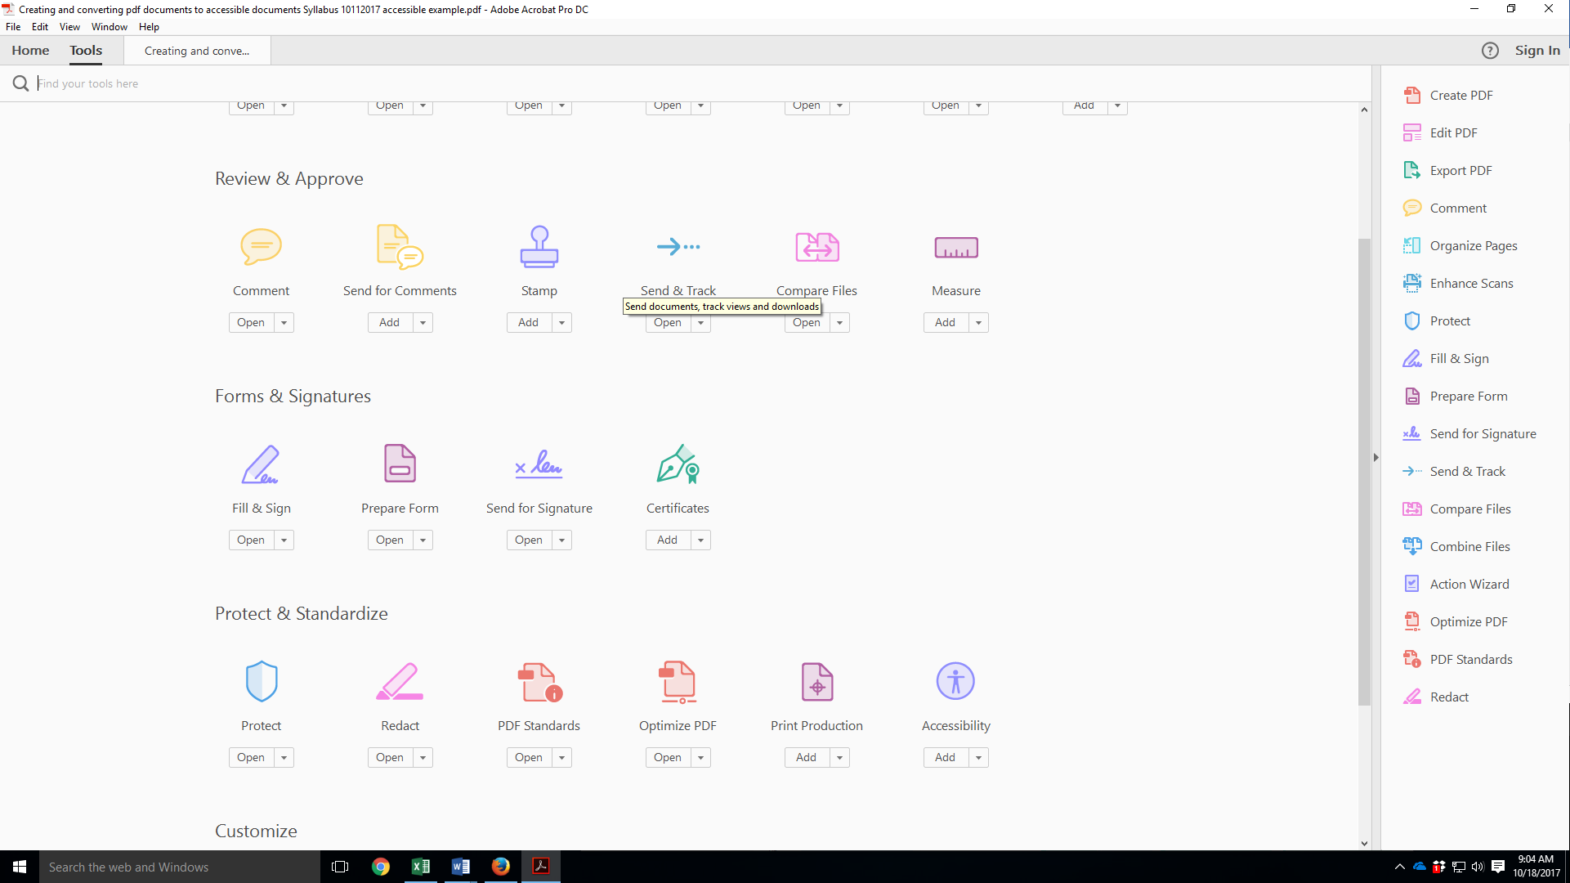
Select Add.
Edit the .pdf file to accessible: The steps below will direct you to links that explain the exact steps required to check for accessible failures and the steps required edit the failures.
- On the right side of your document, select the Accessibility Icon. A new window will appear.
- Select the Full Check option. Another new window will appear.
Select Full Check.

- Use the default to Select All, then select the Start Checking option.
Select Start Checking.
Select Select All.
- On the left of your screen, a new Accessibility menu will open. This menu includes the non-accessible issues found during the Full Check process. In the screen shot below, there are three (3) issues with the Document. If there were issues with the other topics listed, they would be followed by parenthesis that lists the number of issues (e.g. Page Content (2 issues)).
Each topic includes the number of issues found.

Editing Failed issues: Adobe Acrobat Pro includes a feature that will automatically fix the document’s issues. Or you may manually review and edit the issues. This instruction will include the steps to automatically fix some issues and it will instruct you to use a website that will guide you through the steps to manually fix some issues.
- On left menu you will see a list of items that are checked.
- Select the arrow for the item descriptions that includes the words (issues). You will see a list of items that may include:
  - Passed (check mark)
  - Needs manual review (question mark)
  - Failed (X)
  - Note: As a best practice, clear/correct all Failed issues. The Manual Review items cannot be cleared automatically, but you may review and correct them.
Each topic includes an indicator. This topic (Title – Failed).
- Select the issue that you want to correct, the text will be shaded.
Click on the topic until it is shaded.
- Select the list icon that is located in the upper left corner of your list.
- From the menu select the option Fix.
  - Notes: 1) You may get a message that says the document already has an attached report. Do you want to replace it? Select, Replace attached report. 2) If the issue cannot be reworked by Adobe, the Fix option will not be available.
Select Fix.
Select the List icon.
- Notice that after you select the Fix option that the issue you selected will indicate that it Passed the review.
- Repeat steps 1 through 4 until all the of Failed issues are changed to the Passed status.
Manually Editing Failed Issues and Need Manual Review Issues: This section is intentionally written generically since there are too many issues to document and Adobe has already documented the instructions to remedy issues on their website.
- On the left menu, you will see a List icon.
- Use the down arrow to open the menu, select the Show Report option.
Select Show Report.

- You will see a detailed list of rules, status and a description. In the example below, you will see that there are two Rule Names that have a status where you would need to manually check the content.
View the status for each rule.
- When you identify a topic (Rule Name) that cannot be fixed by Adobe, click on the Rule name hyperlink.
Click on the hyperlink.
- A new website will open that includes the instruction and a description of the issue.
- Follow the instructions provided by Adobe Acrobat Pro website.
- Once you have reviewed, corrected or accepted the Rule Name, complete steps 1 – 6 for the other Rule Name issues that cannot be automatically fixed by Adobe.

.pdf to Word
If you have a .pdf file, but not the original Word document, you may convert it to a Word document – if you have copyright/permission to do so.
Converting a .pdf to Word: It is assumed that the .pdf is not your work and therefore, the accessibility changes will be performed either in Adobe Acrobat Pro or you will convert the document to a Word document to finalizes the changes. These instructions include only those edits that are required to make your document accessible. If you are editing a .pdf that is some else’s work, it is a best practice to avoid changing the content or meaning of their work.
- Open the .pdf file that you want to convert to Word.
- Select the File option from the main menu.
- In the new window, select the option to Export To, then select Microsoft Word and then select the Word Document option.
Select Export To.

Select Microsoft Word.
Select Word Document.
Word to Accessible Format
- Use MU’s Accessibility Checklist to determine what needs to be changed and then follow the steps outlined in MS Word Accessibility on-line instructions.
- It is a best practice to add a statement at the bottom of the document that indicates that you have modified the original document for accessibility purposes only and that the original content was not changed.

